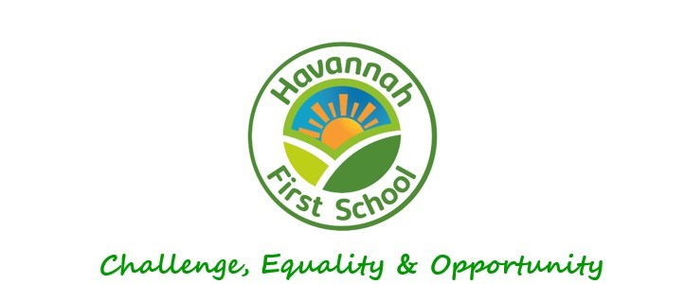
The School Council

Havannah First School

Keeping Children Safe and Happy in School

Rationale

All children at Havannah First School have the right to play and learn happily and safely in school. Our school provides a helpful, caring, friendly and safe environment for everybody.

Definition

A school council is a classroom elected body of pupils whose purpose is to represent their classes and be a forum for active and constructive pupil input into the daily life of the school.

The Importance of School Councils

Article 12 of the United Nations Convention on the Rights of the Child (UNCRC) states that children and young people should have a say in decisions that affect their lives. A School Council can provide a meaningful way in which pupils can voice their opinions and have their views taken into account in decisions which impact upon them.

Aims, beliefs and expectations

We all aim to:
- Be kind to each other
- Respect one another
- Help each other
- Make sure everyone is safe and happy

Guidelines for good practice

At Havannah First School we:
- Are always impressed by children who are friendly, kind and caring
- Reward and praise good behaviour
- Use opportunities in the classroom, through learning activities and in assemblies to reinforce the school’s Golden Rules
- Recognise our emotions and use the Zones of Regulation to regulate how we are feeling
- Teach children and adults that hurtful behaviour in any form will not be accepted
- Teach children that any form of hurtful or dangerous behaviour should always be reported to an adult in school

Roles and responsibilities

The role of the Adults in School
- Class teachers devise a list of classroom and playground rules with the children and ensure that they are valued
- Class teachers and other adults in School celebrate good behaviour whenever possible and have high expectations of children’s behaviour throughout the school and in the playground
- Class teachers and other adults in our School should work with and support the children involved in any hurtful behaviour situations
- They should treat all children fairly
- Class teachers and adults will always make time to listen to children
- Class teachers always report a serious incidents to the headteacher and to parents

The role of the Head Teacher
- Ms McKenna and Mr Burnett are responsible for running the school and ensuring that the behaviour is good throughout the school and that everyone in school is safe
- Ms McKenna and Mr Burnett will have a listening ear, listening to children and adults and taking their thoughts and concerns seriously
- Ms McKenna and Mr Burnett will talk to all staff on a regular basis about behaviour in class, around the school and in the playground, and ensure high standards are maintained
- Ms McKenna and Mr Burnett will talk to parents about any serious incidents and ensure that the matter has been dealt with properly
- Ms McKenna will seek help from others if she thinks children are unsafe and need extra help

The role of the Children
- We will tell an adult if we see someone who is hurt, upset or in danger
- We will talk to an adult in school about anything which worries us or makes us feel uncomfortable
- We will follow the Golden Rules and help others to do the same
- We will follow the No Outsiders ideas and welcome everyone, making sure no one feels like an outsider in our school
- We will use the Zones of Regulation to recognise our feelings and make good choices
- We will develop our resilience by seeing challenges as an opportunity to learn
- We will stay in safe places in school and make safe choices
- We will think about how other people feel and make sure we never deliberately make someone else feel bad

Conclusion
We want to be happy, confident and safe during our time at school. Everyone in our Havannah First School Family is proud of our caring, friendly, secure and safe school.

Agreed by the School Council on Thursday 21st September 2023

