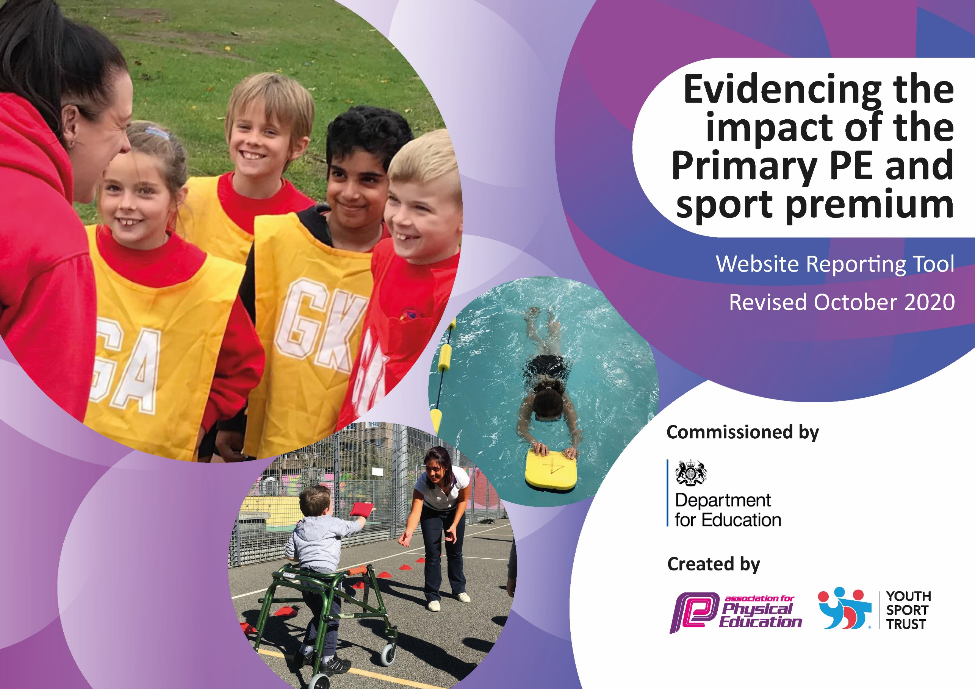
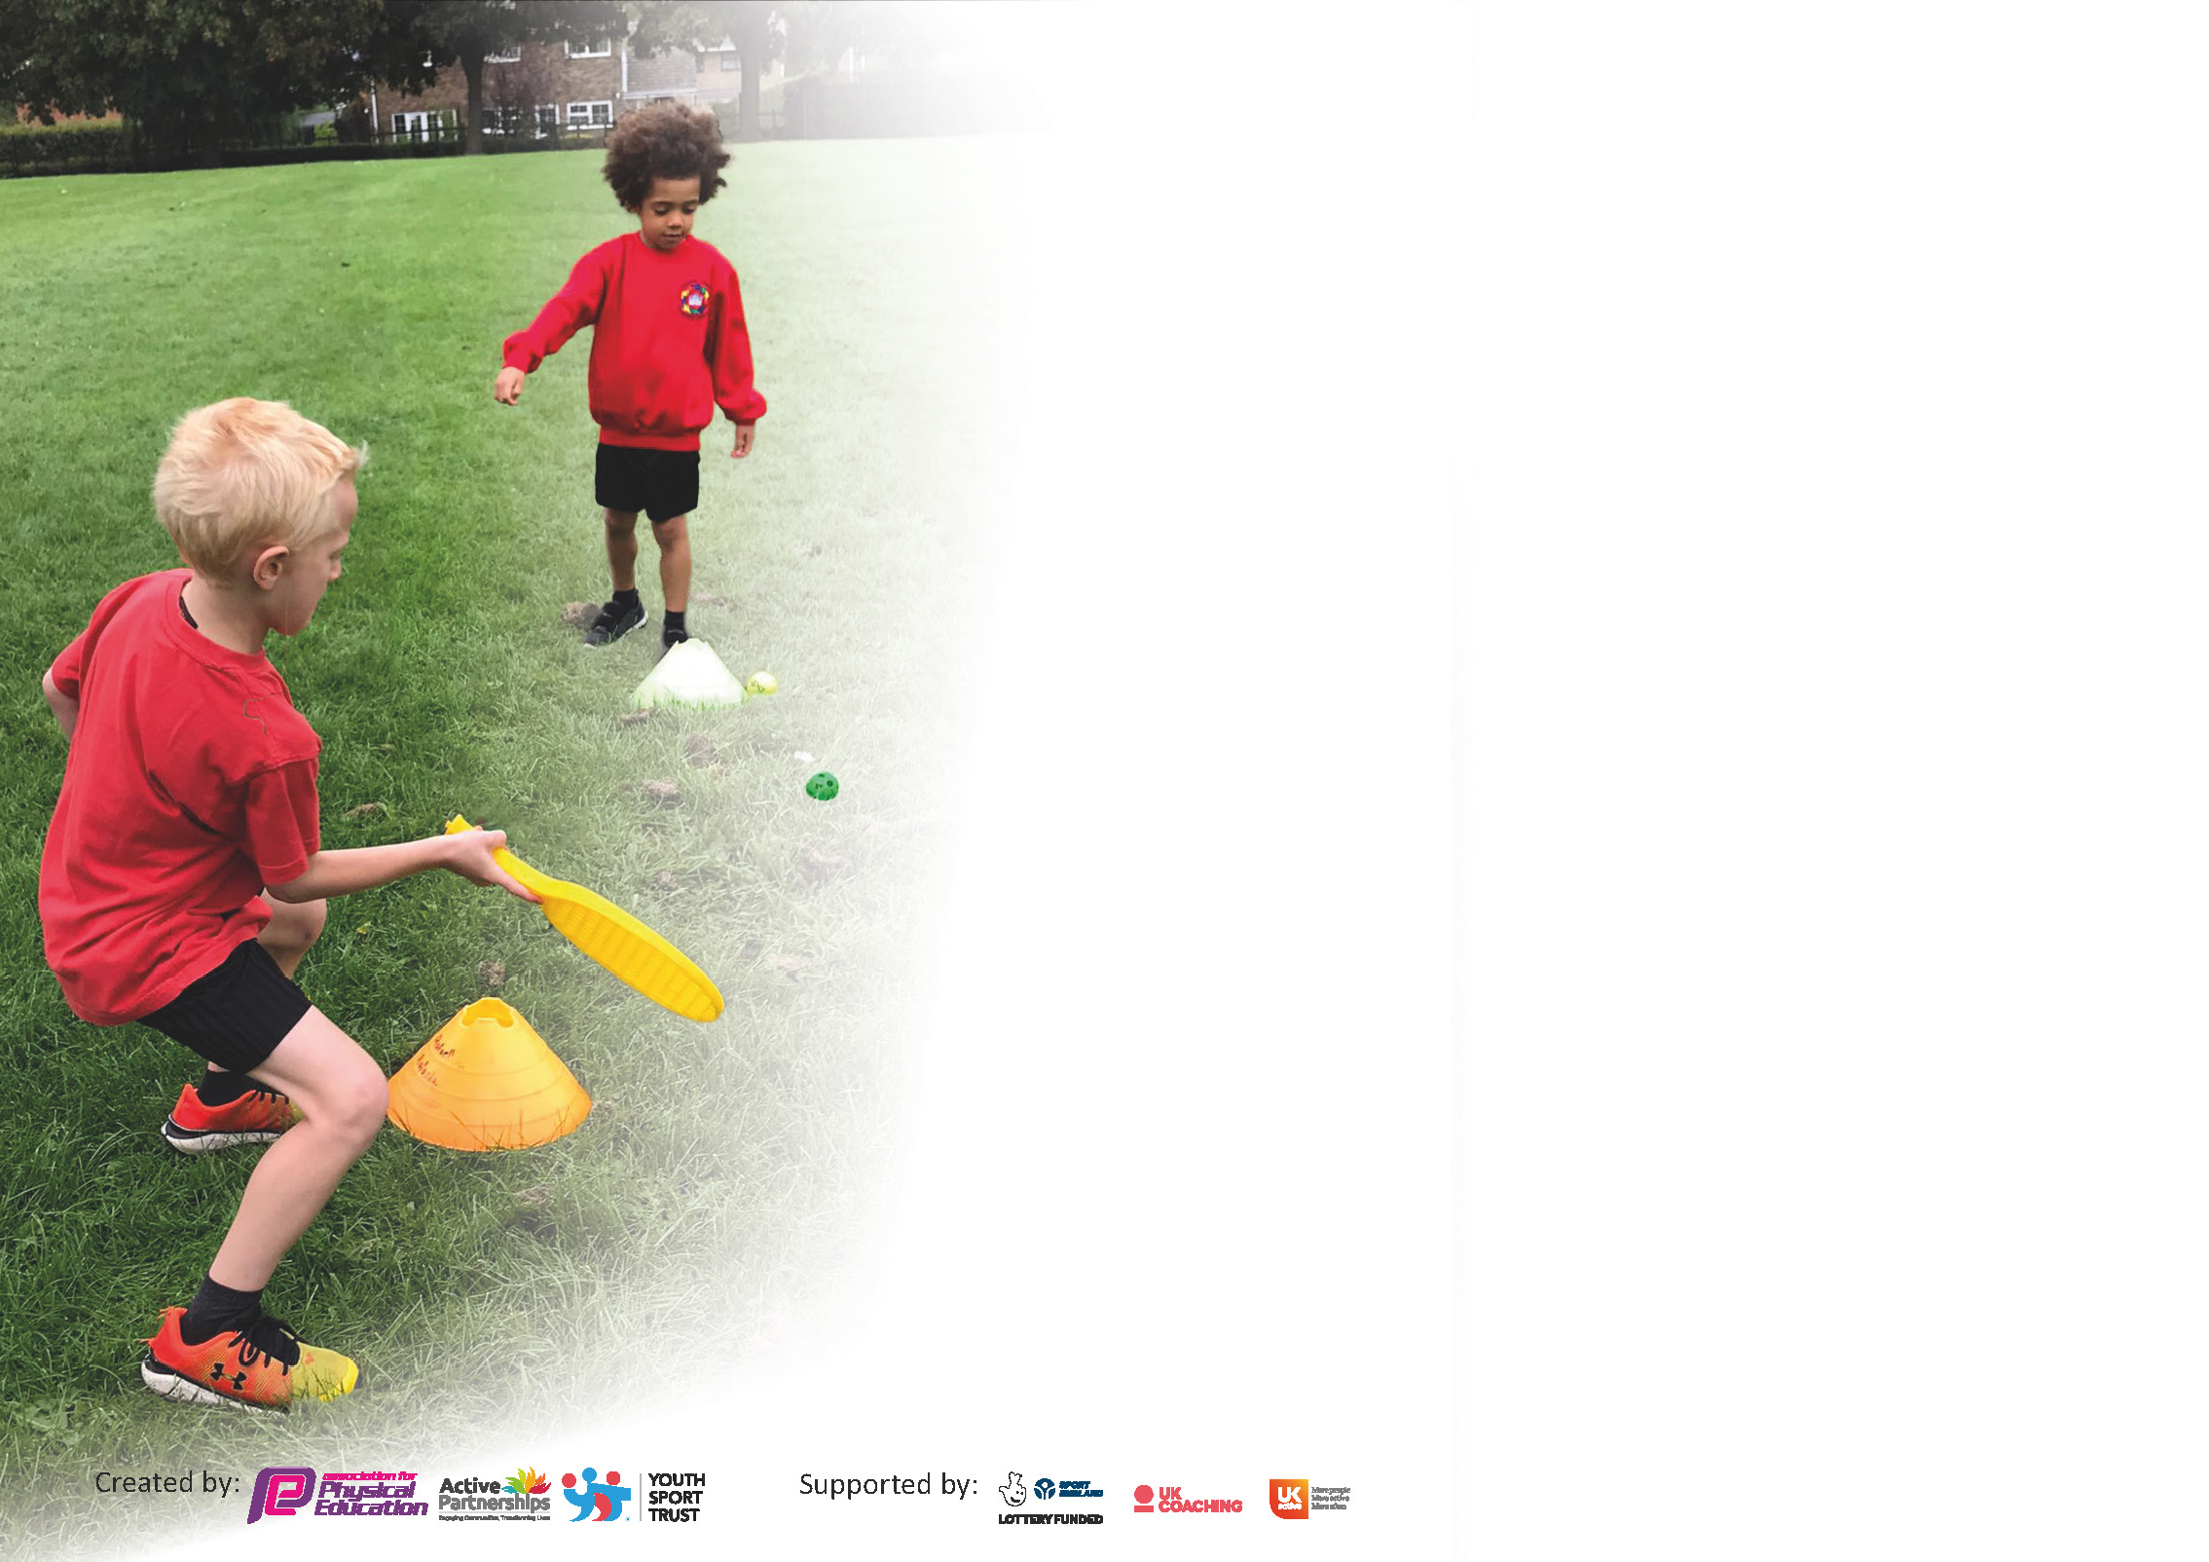

It is important that your grant is used effectively and based on school need. The Education Inspection Framework (Ofsted 2019 p64) makes clear there will be a focus on ‘whether leaders and those responsible for governors all understand their respective roles and perform these in a way that enhances the effectiveness of the school’.

Under the Quality of Education criteria (p41) inspectors consider the extent to which schools can articulate their curriculum (INTENT), construct their curriculum (IMPLEMENTATION) and demonstrate the outcomes which result (IMPACT).

To assist schools with common transferable language this template has been developed to utilise the same three headings which should make your plans easily transferable between working documents.

Schools must use the funding to make additional and sustainable improvements to the quality of Physical Education, School Sport and Physical Activity (PESSPA) they offer. This means that you should use
the Primary PE and sport premium to:

- Develop or add to the PESSPA activities that your school already offer
- Build capacity and capability within the school to ensure that improvements made now will benefit pupils joining the school in future years

Please visit gov.uk for the revised DfE guidance including the 5 key indicators across which schools should demonstrate an improvement. This document will help you to review your
provision and to report your spend. DfE encourages schools to use this template as an effective way of meeting the reporting requirements of the Primary PE and sport premium.

We recommend you start by reflecting on the impact of current provision and reviewing the previous spend.

Schools are required to publish details of how they spend this funding as well as on the impact it has on pupils’ PE and sport participation and attainment by the end of the summer term or by 31st July 2021 at the latest.

** In the case of any under-spend from 2019/20 which has been carried over this must be used and published by 31st March 2021.

We recommend regularly updating the table and publishing it on your website throughout the year. This evidences your ongoing self-evaluation of how you are using the funding to secure maximum, sustainable impact. Final copy must
be posted on your website by the end of the academic year and no later than the 31st July 2021. To see an example of how to complete the table please click HERE.
Created by: Supported by:

Please note: Although there has been considerable disruption in 2020 it is important that you publish details on your website of how you spend the funding - this is a legal requirement.
Support for review and reflection - considering the 5 key indicators from DfE, what development needs are a priority for your setting and your pupils now and why? Use the space below to reflect on previous spend and key achievements and areas for development.

N.B. In this section you should refer to any adjustments you might have made due to Covid-19 and how these will influence further improvement.
Key achievements to date until July 2021: | Areas for further improvement and baseline evidence of need:
- Continued CPD in some of the gaps using visiting coaches  - Continued use of intervention programmes based on the assessment data  - During January Lockdown we continued to use our external providers for Key Worker and Vulnerable children. | To re-establish pre-Covid PE including before and after school clubs.  To re-establish use of the hall for Gymnastic and Dance (Guidance and risk assessment depending)  To re-establish  CPD for established new areas of the curriculum

Did you carry forward an underspend from 2019-20 academic year into the current academic year?
YES

If YES you must complete the following section
If NO, the following section is not applicable to you

If any funding from the academic year 2019/20 has been carried over you MUST complete the following section. Any carried over funding MUST be spent by 31 March 2021.
Academic Year: September 2020 to March 2021 | Total fund carried over: £ | Date Updated:31.7.21
What Key indicator(s) are you going to focus on? |  |  |  | Total Carry Over Funding:
 |  |  |  | £4.000
Intent | Implementation |  | Impact
Your school focus should be clear how you want to impact on your pupils.  To upskill teaching staff across the curriculum.  To create more active playtimes within Covid bubbles. | Make sure your actions to achieve are linked to your intentions:  The use of NUF to support every key stage across school.  Key stage One  Multi-skills and Football  Reception  Fundamental movement skills  Intervention  Key Stage Two  Striking and Fielding and Football  Through staff confidence surveys Key Stage Two had a gap in Knowledge for Hockey. Newcastle PE and School Sports service came in to work across Key stage Two.  Staff in Early Years had coaching for fundamental movements to address the gaps left by lockdown and missed time in Nursery.  Key Stage One Staff chose to be upskilled in Dance as this was an area of CPD lacking in recent years.  Purchase of balls for each bubble.  Purchase of coloured playground kits. | Carry over funding allocated:  £2,850.00  £675.00  £75.90  £271.80 | Evidence of impact: How can you measure the impact on your pupils; you may have focussed on the difference that PE, SS & PA have made to pupils re-engagement with school. What has changed?:  Staff across the whole school have been upskilled in teaching these areas of the curriculum.  Planning has been received to ensure that staff have the confidence to deliver hockey/ Fundamental movement and dance themselves.  Due to each bubble having different coloured equipment, it enabled us to assign a colour to each bubble and reduce the risk of Covid infection, whilst having active playtimes. | Sustainability and suggested next steps and how does this link with the key indicators on which you are focussing this academic year?:  Continue with support for next year in new areas.  Re-establish play leaders to introduce playground kits.

Meeting national curriculum requirements for swimming and water safety.

N.B Complete this section to your best ability. For example you might have practised safe self-rescue techniques on dry land.
What percentage of your current Year 6 cohort swim competently, confidently and proficiently over a distance of at least 25 metres?  N.B. Even though your pupils may swim in another year please report on their attainment on leaving primary school at the end of the summer term 2020. | %
What percentage of your current Year 6 cohort use a range of strokes effectively [for example, front crawl, backstroke and breaststroke]? | %
What percentage of your current Year 6 cohort perform safe self-rescue in different water-based situations? | %
Schools can choose to use the Primary PE and sport premium to provide additional provision for swimming but this must be for activity over and above the national curriculum requirements. Have you used it in this way? | No

Action Plan and Budget Tracking
Capture your intended annual spend against the 5 key indicators. Clarify the success criteria and evidence of impact that you intend to measure to evaluate for pupils today and for the future.

Academic Year: 2020/21 | Total fund allocated: £17.768.00 | Date Updated:31.7.21
Key indicator 1: The engagement of all pupils in regular physical activity – Chief Medical Officers guidelines recommend that primary school pupils undertake at least 30 minutes of physical activity a day in school |  |  |  | Percentage of total allocation:
 |  |  |  | %
Intent | Implementation |  | Impact
Your school focus should be clear what you want the pupils to know and be able to do and about  what they need to learn and to  consolidate through practice: | Make sure your actions to achieve are linked to your intentions: | Funding allocated: | Evidence of impact: what do pupils now know and what can they now do? What has changed?: | Sustainability and suggested next steps:
To keep children active during lockdown and on the return to school | - Early Years will use Dough- Disco daily and BBC Super Movers has been recommended for staff to use as movement breaks/ active lessons.  - Use of Go-Noodle in Class for brain breaks and during wet playtimes, has been periodic due to Covid Risk Assessment.  - For each class to run the daily mile on the days that they don’t have PE.  - During this academic year PE has been restricted to the outdoors, but all classes have still had two hours of timetabled PE (Weather dependent)  - Intervention clubs for those pupils who have been identified as struggling to adapt to life post lockdown. e.g, confidence/ lack of physical activity.  - Shared PE lessons and encouraged families at home to get out on their daily walks, as we did in the previous lockdown. |  | - Improved fine motor skills in Early Years.  - More children have had active playtimes.  - The children have enjoyed being active  - Some normality was returned to the School Day following Lockdown.  - Children have enjoyed outdoor PE, showing resilience in all weathers, other than heavy snow which meant that coaches were unable to deliver, but instead worked with the children to build snowmen.  - Those children who have accessed intervention have developed confidence, improved social skills and have benefited from physical activity. Year One in particular missed a huge chunk of Early Years and these groups have helped with the transition into Key Stage One.  - We had a high level of response to PE lessons set on SeeSaw. | - Focus on CPD for Reception staff.  - Look at Bike for Health delivering balance bike sessions for Reception.  - NUF to be booked for a full day for the next academic year. This will ensure that children who missed out on Key Stage One coaching due to Covid lockdowns will benefit from coaching in Key Stage Two. As part of the day package NUF will deliver a lunchtime club next year with a focus on Covid response.  - Intervention group with the PE Service to meet gaps in the curriculum.
Key indicator 2: The profile of PESSPA being raised across the school as a tool for whole school improvement |  |  |  | Percentage of total allocation:
 |  |  |  | %
Intent | Implementation |  | Impact
Your school focus should be clear what you want the pupils to know and be able to do and about  what they need to learn and to  consolidate through practice: | Make sure your actions to achieve are linked to your intentions: | Funding allocated: | Evidence of impact: what do pupils now know and what can they now do? What has changed?: | Sustainability and suggested next steps:
To promote PE and Sport throughout the school during lockdown  To celebrate sporting achievements, through online achiever’s assemblies.  For pupils to understand the importance of PE  Intervention groups run by both the Sports service and Lee Sterry Sports  To promote PE through the use of social media  To promote PE around the school through display.  To share more information with parents | - On social media we shared the PE Sports Service’s quick challenges  - On Seesaw, we also shared the weekly Newcastle PE and Sports Service PE lessons for both Key /Stage One and Two.  - During lockdown we shared PE challenges on twitter and Seesaw from the Newcastle PE Sports Service.  - We promoted and encourage the children to participate in PE with Joe Wicks.  - Class Dojos have been awarded for achievement/effort during PE lessons  - Through the teaching of health and hygiene as part of our Science teaching.  - Staff to identify those children whose physical activity has been affected by lockdown back to being active and enjoying it.  - PE and Sport is promoted through Twitter, school newsletters and SeeSaw.  - Our PE Noticeboard will show our curriculum and intentions as well as displaying our School Games Awards. |  | - To offer opportunities for children and their families to remain active, which they shared with us through See Saw.  - Newcastle PE Service saw that many children from across the city were engaged with their online PE lessons.  - Children are being recognised for their hard work and dedication in PE and Sport.  - Due to Covid and the government’s continuous message to exercise and eat well, we found that children and families have been more active together than previously.  - Improved confidence, social skills have improved, and the children are beginning to enjoy being active again.  - High parental engagement with social media. | - Keep these resources to reshare in case of any future isolations.  Back to face-to-face Achiever Assemblies next Academic year.  - Continue to share the message of how important physical activity is.

Key indicator 3: Increased confidence, knowledge and skills of all staff in teaching PE and sport |  |  |  | Percentage of total allocation:
 |  |  |  | 38.94%
Intent | Implementation |  | Impact
Your school focus should be clear | Make sure your actions to | Funding | Evidence of impact: what do | Sustainability and suggested
what you want the pupils to know | achieve are linked to your | allocated: | pupils now know and what | next steps:
and be able to do and about | intentions: |  | can they now do? What has
what they need to learn and to |  |  | changed?:
consolidate through practice:
To upskill teachers so that they have the knowledge to deliver high quality PE across the curriculum.  To purchase Newcastle and PE School Sports Service Gold SLA  (We have been unable to fulfil all of the elements due to Covid and school restrictions)  Release time for PE Lead. | - Visiting coaches throughout the year are teaching different areas of PE to provide new CPD.  - Meetings with PESSS and Gosforth Trust PE Leads.  - A Staff meeting will be provided by PESSS following Autumn Assessments. (Staff to go through data and choose those pupils that need more support.)  - Each half term PE lead has a meeting with PESSS who updates on any updated PE guidance.  - To review and develop all aspects of the PE curriculum including the impact statement.  - To plan for PE for the next academic year with the aim of getting PE back to as close to normal as possible. | PESSS  £1125.00  Lee Sterry  £2070.00  NUF  Paid using underspend from 2019/20.  Newcastle Falcons  £500  SLA PESSS  £2995.00  £50.00 Sports Service Support  For K.G to support SM  £180.00  Supply cover over one day. | - Children in Key Stage One gained experience in throwing and catching, football and Dance.  - Children in Key Stage two took part in striking and fielding, Hockey and Rugby.  - Children in Reception were coached in fundamental movement and football.  - PE Lead able to plan the PE curriculum for 2021-22, based on prior experience of coaching and staff training needs. | - Following our links with Newcastle Falcons in the Summer term, we intend to book them for coaching Key stage two in 2021 with a view to competing in a Rugby festival organised within Gosforth Trust.  - Continue with CPD for next academic year with NUF and the PE Service, filling gaps within the teacher’s knowledge and confidence.  - Half termly release time with Supply paid by sports premium money for PE Lead to further develop PE and Sport in 2021-22. This will be pertinent with the move to a new School site planned for Easter 2022.
Key indicator 4: Broader experience of a range of sports and activities offered to all pupils |  |  |  | Percentage of total allocation:
 |  |  |  | 26.83%
Intent | Implementation |  | Impact
Your school focus should be clear | Make sure your actions to | Funding | Evidence of impact: what do | Sustainability and suggested
what you want the pupils to know | achieve are linked to your | allocated: | pupils now know and what | next steps:
and be able to do and about | intentions: |  | can they now do? What has
what they need to learn and to |  |  | changed?:
consolidate through practice:
Additional achievements:  For children to engage with and enjoy a range of sporting activities.  To offer new coaching experience for both staff and pupils.  For pupils that are taking part in interventions to enjoy different activities. | HAL delivered on School site by PPESSS  - Outdoor adventurous day (in place of Robin Wood due to Covid) For Key Stage Two children (paid for by parents)  - Visiting coaches will be delivering different sports and activities following last year’s coaching.  - Various activities provided by different external providers. We will be working with Bike 4 Health to assess children in Key Stage 2 and provide a cycling programme for those children with limited skills and experience.  - Balance Bikes purchased for Early Years  - Whole School Sports day and possible sports week planned for the summer term.  - During lockdown we shared PE challenges on twitter and Seesaw from the Newcastle PE Sports Service.  - We promoted and encouraged the children to participate in PE with Joe Wicks. | £1.770.00  £2.998.50 | - This year the children in both Year 2 and Year 3 enjoyed the challenges set in the HAL festivals run by the PESSS  - Increased confidence and cycling skills for Key Stage 2 targeted group.  - 30 Balance Bikes have been ordered for Early Years to give new starters the early experience needed to cycle.  - A high engagement of children responding to activities set through our seesaw app | - Continue to engage with the HAL festivals next academic year.  - Return to Outdoor adventurous learning at Robin Wood if possible, if not then a suitable on site or local alternative to be organised.  - Continue with intervention groups focusing on different groups of children each half term.

Key indicator 5: Increased participation in competitive sport |  |  |  | Percentage of total allocation:
 |  |  |  | %
Intent | Implementation |  | Impact
Your school focus should be clear | Make sure your actions to | Funding | Evidence of impact: what do | Sustainability and suggested
what you want the pupils to know | achieve are linked to your | allocated: | pupils now know and what | next steps:
and be able to do and about | intentions: |  | can they now do? What has
what they need to learn and to |  |  | changed?:
consolidate through practice:
To offer all children a competitive opportunity | - To take part in Schools 500 (Activ5) on own school site. All children are able to take part with only the top scores being shared with the PSSS. If the year group win across the city all children will receive a certificate.  - Lee Sterry to provide a football tournament for schools in the Gosforth trust. (This planned event was cancelled by the provider) |  | - Pupils loved taking part in this event and they really engaged with the competition element. We were rewarded by our Key Stage One Team being awarded 3rd place across both Newcastle and Tyne and Wear. | - Continue to participate in inter- school competitions as they open up next academic year.  £6079.50 held back and carried over to next year to fund a full day of NUF coaching as part of our Covid recovery plan.  This will also be used to cover the cost of new equipment and PE storage for our expansion to 3 form entry at our new school site.

Signed off by
Head Teacher:
Date:
Subject Leader: | S. McMillan
Date: | 31.7.21
Governor:
Date:

