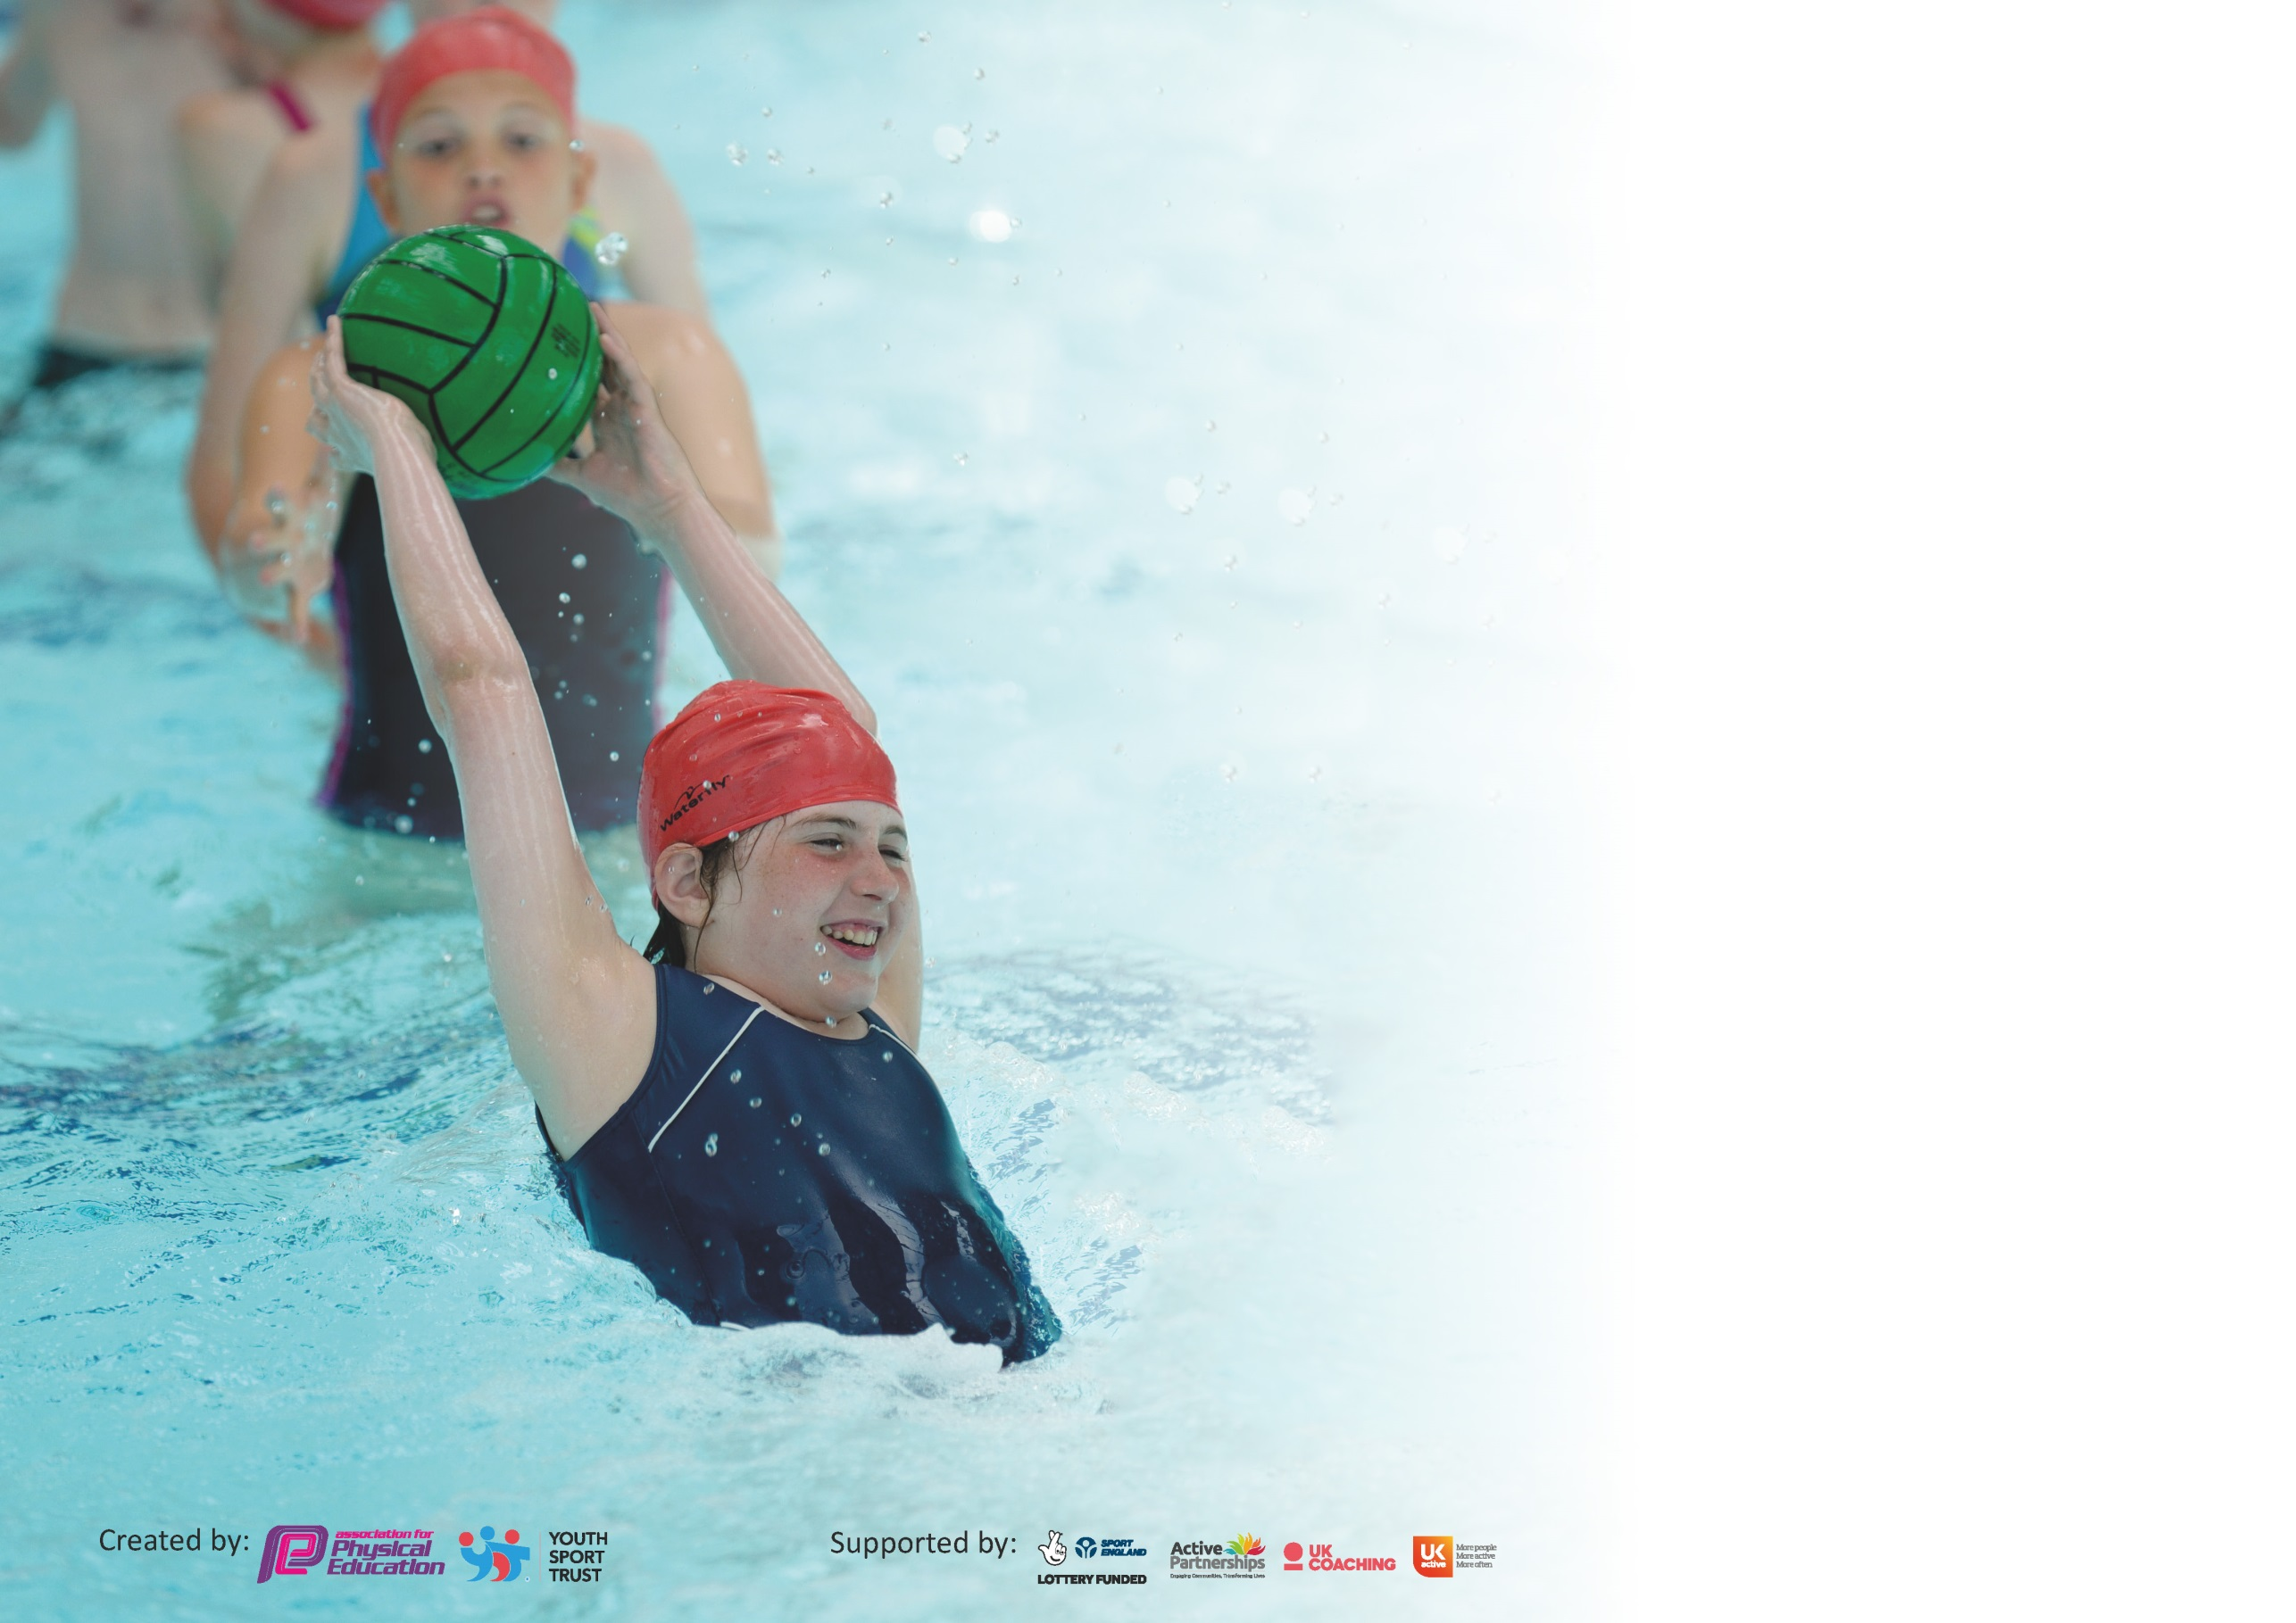

It is important that your grant is used effectively and based on school need. The Education Inspection Framework (Ofsted 2019 p64) makes clear there will be a focus on ‘whether leaders and those responsible for governors all understand their respective roles and perform these in a way that enhances the effectiveness of the school’.

Under the Quality of Education criteria (p41) inspectors consider the extent to which schools can articulate their curriculum (INTENT), construct their curriculum (IMPLEMENTATION) and demonstrate the outcomes which result (IMPACT).

To assist schools with common transferable language this template has been developed to utilise the same three headings which should make your plans easily transferable between working documents.

Schools must use the funding to make additional and sustainable improvements to the quality of Physical Education, School Sport and Physical Activity (PESSPA) they offer. This means that you should
use the Primary PE and Sport Premium to:

- Develop or add to the PESSPA activities that your school already offer
- Build capacity and capability within the school to ensure that improvements made now will benefit pupils joining the school in future years

Please visit gov.uk for the revised DfE guidance including the 5 key indicators across which schools should demonstrate an improvement. This document will help you to review your provision and to report your spend. DfE encourages schools to use this template as an effective way of meeting the reporting requirements of the Primary PE and Sport Premium.

We recommend you start by reflecting on the impact of current provision and reviewing the previous spend.

Schools are required to publish details of how they spend this funding as well as on the impact it has on pupils’ PE and sport participation and attainment by the end of the summer term or by 31st July 2020 at the latest.

We recommend regularly updating the table and publishing it on your website throughout the year. This evidences your ongoing self-evaluation of how you are using the funding to secure maximum, sustainable impact. Final copy must be posted on your website by the end of the academic year and no later than the 31st July 2020. To see an example of how to complete the table please click HERE.

Support for review and reflection - considering the 5 key indicators from DfE, what development needs are a priority for your setting and your pupils now and why? Use the space below to reflect on previous spend and key achievements and areas for development.

Key achievements to date until July 2020: | Areas for further improvement and baseline evidence of need:
- Continued CPD in some of the gaps using visiting coaches
- Continued use of intervention programmes based on the assessment data
- Addition of the Sport Reps to promote PE and Sport across the school.

Meeting national curriculum requirements for swimming and water safety.
What percentage of your current Year 6 cohort swim competently, confidently and proficiently over a distance of at least 25 metres?  N.B. Even though your pupils may swim in another year please report on their attainment on leaving  primary school at the end of the summer term 2020. | %
What percentage of your current Year 6 cohort use a range of strokes effectively [for example, front crawl, backstroke and breaststroke]? | %
What percentage of your current Year 6 cohort perform safe self-rescue in different water-based situations? | %
Schools can choose to use the Primary PE and Sport Premium to provide additional provision for swimming but this must be for activity over and above the national curriculum requirements. Have you used it in this way? | Yes/No

Action Plan and Budget Tracking
Capture your intended annual spend against the 5 key indicators. Clarify the success criteria and evidence of impact that you intend to measure to evaluate for pupils today and for the future.

Academic Year: 2019/20 | Total fund allocated: £17,768.00 | Date Updated:
Key indicator 1: The engagement of all pupils in regular physical activity – Chief Medical Officer guidelines recommend that primary school pupils undertake at least 30 minutes of physical activity a day in school |  |  |  | Percentage of total allocation:
 |  |  |  | 1.5%
Intent | Implementation |  | Impact
Your school focus should be clear what you want the pupils to know and be able to do and about  what they need to learn and to  consolidate through practice: | Make sure your actions to achieve are linked to your intentions: | Funding allocated: | Evidence of impact: what do pupils now know and what can they now do? What has changed?: | Sustainability and suggested next steps:
To achieve the Active 30 minutes within the classroom.  To achieve the active 30 minutes outside of the Classroom  For all children to do 2 hours of PE per week.  To provide more opportunities for children to take part in extra-curricular activities.  To provide opportunities for children to attend both HAL activities and competitive events.  To encourage children to be more active outside of school  Pupils to be more active during lunchtime  To engage more pupils in physical activity | - Early Years will use Dough- Disco regularly and BBC Super Movers has been recommended for staff to use as movement breaks/ active lessons.  - Continue with regular running laps on each day a class has no PE.  - Use of Go-Noodle in Class for brain breaks and during wet playtimes.  - For each class to run the daily mile on the days that they don’t have PE.  - Playground leaders Deployment of skipping squad at break and lunchtime.  - Children are encouraged to be more active on the Playground through Achiever Certificates awarded by the Sport Reps.  - Continue to train pupils to be playground leaders.  - Intervention clubs for those pupils who need more support from the assessment data.  - Change 4 life clubs such as girls zumba club/ SEN club etc. | Coaches to HAL Festivals £268.00  Service Level Agreement with PESSS training Play-Leaders and providing assessment and running intervention groups for those needing support –See Key Indicator 3 | - More children have had active playtimes.  - More children have been involved in skipping, games resulting in more settled playtimes.  - The children have enjoyed being active. | Following lock-down it is more important than ever to ensure the active 30 minutes, maintaining health and fitness. Mental health will also be a priority, exercise and PE and Sport will be will help to alleviate anxiety and Mindfulness and calming activities can be accessed through Go- Noodle.
Key indicator 2: The profile of PESSPA being raised across the school as a tool for whole school improvement |  |  |  | Percentage of total allocation:
 |  |  |  | 0.18%
Intent | Implementation |  | Impact
Your school focus should be clear what you want the pupils to know and be able to do and about  what they need to learn and to  consolidate through practice: | Make sure your actions to achieve are linked to your intentions: | Funding allocated: | Evidence of impact: what do pupils now know and what can they now do? What has changed?: | Sustainability and suggested next steps:
To promote PE and Sport throughout the school  To celebrate sporting achievements  For pupils to understand the importance of PE  To get more girls active within PE/football  To promote PE through the use of social media  To promote PE around the school through display.  To share more information with parents | - Sports Reps are encouraging children to be more active and promoting PE by presenting awards in Achievers assemblies.  - A girl and a boy from our play leaders will represent PE and Sport in School Council Meetings.  - This year we will continue to use our NUF breakfast club as a girls’ football club.  - PE and Sport is promoted through Twitter, school newsletters and SeeSaw.  - Our PE Noticeboard will show our curriculum and intentions as well as displaying our School Games Awards. | Skipping Squad caps  £33.75 | - More children are active at playtime  - The Sports Reps took great responsibility for the role of presenting awards and even chose the recipient for an active playtime award from NUF.  - Through discussion with PESSS the idea of sports reps was suggested as an additional way of promoting PE and School Sport.  - We received the virtual school games award from PE and School Sport recognising our continued engagement and commitment to the promote PE and Sport through Twitter and SeeSaw during Lockdown. | Next academic year continue with Sports Reps from new year 4s- this worked very well.  Continue to use Seesaw as a platform to promote PE and Sport to the whole school- setting challenges and promoting events.

Key indicator 3: Increased confidence, knowledge and skills of all staff in teaching PE and sport |  |  |  | Percentage of total allocation:
 |  |  |  | 43.73%
Intent | Implementation |  | Impact
Your school focus should be clear | Make sure your actions to | Funding | Evidence of impact: what do | Sustainability and suggested
what you want the pupils to know | achieve are linked to your | allocated: | pupils now know and what | next steps:
and be able to do and about | intentions: |  | can they now do? What has
what they need to learn and to |  |  | changed?:
consolidate through practice:
To increase staff confidence in delivering high quality PE lessons  For PE Lead to continue to develop PE within the School  To provide staff with data to support the teaching of Fundamental Movement skills  PE lead to continue to receive updates through trust meeting with Sports Service. | - Visiting coaches throughout the year are teaching different areas of PE to provide new CPD.  - Meetings with PESSS and Gosforth Trust PE Leads.  - A Staff meeting will be provided by PESSS following Autumn Assessments. (Staff to go through data and choose those pupils that need more support.)  - Each half term PE lead has a meeting with PESSS who updates on any updated PE guidance. | SLA PESSS  £2240.00  NUF  £4000.00  Lee Sterry  £1530.00 | - Children in K.S 2 gained experience and coaching in cricket, netball, hockey and dance.  Gymnastics, athletics and tennis were also planned before school closure.  - Children identified by whole school assessments received lunch time intervention provided by the PESSS. | Continue with our SLA and assessment programme in 2020/21  Plan for visiting coaches to teach a new variety of sports in 2020/21 upskilling staff further.
Key indicator 4: Broader experience of a range of sports and activities offered to all pupils |  |  |  | Percentage of total allocation:
 |  |  |  | 32.21%
Intent | Implementation |  | Impact
Your school focus should be clear | Make sure your actions to | Funding | Evidence of impact: what do | Sustainability and suggested
what you want the pupils to know | achieve are linked to your | allocated: | pupils now know and what | next steps:
and be able to do and about | intentions: |  | can they now do? What has
what they need to learn and to |  |  | changed?:
consolidate through practice:
To offer new coaching experience for both staff and pupils.  To provide opportunities to experience new sports and activities.  To renew PE Storage and equipment to make different sports and activities more accessible.  To give girls the opportunity to be coached and compete in football.  To attend HAL Festivals in each Key Stage. | - Visiting coaches will be delivering different sports and activities following last year’s coaching.  - Taster sessions are planned with Northumberland Tennis and Richard Vitty Squash.  - Skipping School coaches to work with Key Stage 2 for the first time with a new K.S 2 Skipping festival planned for the first time.  - New Storage units to organise and centralise PE equipment.  - Planned ordering of new equipment to replace old/worn equipment and ensure enough equipment is available for a class of 30.  - Begin to use Wow, encouraging more children to walk to school.  - Walk to school week and the Big Pedal will be promoted.  - We will be working with Bike 4 Health to assess children in Key Stage 2/ Key Stage One and Reception and provide cycling programme for those children with limited skills and experience.  - Whole School Sports day and possible sports week planned for the summer term. | Yoga Bugs  £600.00  Richard Vitty Squash coaching  £60.00  Skipping School coaching  £100  Storage and Equipment  £888.70  Bike 4 Health coaching  £4075.00 | - New games and opportunities because of new equipment.  - A new love and enjoyment of PE with more children skipping at playtime.  - Increased confidence and cycling skills for Key Stage 2 targeted group.  Due to Covid 19, Key Stage One and Reception did not receive this programme. | We are planning to use PE Premium in the next academic year to provide children with different opportunities and experience of a range of different sports. Included in this list will be some of the coaching that was missed this academic year due to school closure.

Key indicator 5: Increased participation in competitive sport |  |  |  | Percentage of total allocation:
 |  |  |  | 0.73%
Intent | Implementation |  | Impact
Your school focus should be clear | Make sure your actions to | Funding | Evidence of impact: what do | Sustainability and suggested
what you want the pupils to know | achieve are linked to your | allocated: | pupils now know and what | next steps:
and be able to do and about | intentions: |  | can they now do? What has
what they need to learn and to |  |  | changed?:
consolidate through practice:
To compete within our School Trust  To participate in the 2020 500 Games  To participate in School Games events  across the school year. | Within the trust offer a range of activities to different year groups.  Choosing different children within year groups for events.  To select children for competition though in class delivery of sport.  This year we took part in both a trust Football and Basketball tournament. | Coaches to Trust competitions  £130.00 | - Children attended some competitions before school closure for Covid 19 and found pupil enjoyment to be high.  - Because of national school closures many competitions including the 500 games were missed. However, the virtual 500 games was promoted on Seesaw and staff reported high engagement across the school. | Due to Covid 19 the School Games mark was frozen – so that we were unable to gain Platinum status.  We will hold our Gold Award for this year, applying for Platinum in 2020/21.

Signed off by
Head Teacher: | Helen McKenna
Date: | 17.07.20
Subject Leader: | Sally McMillan
Date: | 17.10.20
Governor: | Roksana Rutherford
Date: | 17.10.20

