Challenge, Equality & Opportunity

Parent and Carers’ Guide to Radicalisation and Preventing Extremism

What is radicalisation?
Radicalisation refers to the process by which a person comes to support terrorism and forms of extremism leading to terrorism. It is usually a process not an event. During this process, there will be opportunities to intervene in order to reduce the risk of the individual being attracted to extremist ideology and causes, and safeguard him/her from the risk of radicalisation. It is important to be able to recognise the factors that might contribute towards the radicalisation of an individual. Some factors that lead an individual to becoming radicalised are no different to those that might lead to involvement with or being vulnerable to other activity such as gangs, drugs and sexual exploitation.
Who does it affect?
Those involved in extremist activity come from a range of backgrounds and experiences. There is no single profile of what an extremist looks like or what might drive a young person towards becoming radicalised. It can affect impressionable young boys and men and also impressionable young girls and women. Unfortunately, the recent pandemic has meant that children have spent more time than ever before learning and socialising online. Parents and carers also have to juggle constantly changing technology to navigate and understand the risks children face online.
Why do young people become radicalised?
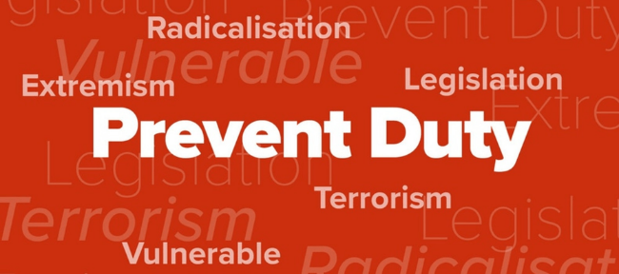
The reasons for young people being drawn into extremist views are many and varied but may include the following:
- They are trying to make sense of world events.
- They feel that their culture or religion is under threat.
- It makes them feel a sense of identity or belonging or being part of something.
- They are looking for adventure or excitement.
- They have a personal grievance or experience of racism or discrimination and feel they want to change things.
- They are under pressure from their peers who have links with these groups.
How are young people radicalised?
Extremist groups use the internet and social media to spread their ideology and recruit vulnerable young people. Extremists are using sites such as Facebook, Twitter, Instagram or YouTube but young people may be invited to join discussions on less well-known sites such as Kik, Whisper, Messenger, Yik Yak or Telegram. Extremists often use these sites because they are harder to monitor and they can hide their identity.
Extremists often manipulate young people by using emotional triggers to engage with them, and may target them when they are experiencing difficulties such as bereavement, emotional trauma, mental health issues or social anxiety.
A common approach used by them is to spread misinformation or fake news to generate anger, outrage or mistrust. Teaching children not to fall for this trick and to actively check facts is one of the most important things we can do to protect our children from online grooming and extremists.
What can schools do?
Notice
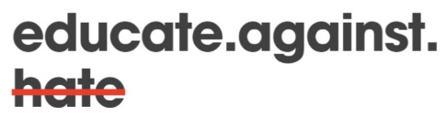
Practitioners should make themselves aware of the factors that might drive somebody towards extremism so they are able to notice them should they present themselves. However, staff using their skill, expertise, and professional judgement is crucial in not stigmatising individuals that may display some of the vulnerability factors highlighted.
Check
If a practitioner is concerned about an individual (child or adult) who is being drawn towards extremist activity, they should check their concerns with their organisation’s Prevent lead and/or designated safeguarding officer to ensure their concerns are valid and well informed.
Share
Where it is recognised that an individual (child or adult) is indeed at risk of radicalisation and involvement in extremist activity, a referral should be made to the local authority and police. If as part of this identification a child or young person is put at risk (either through their own direct involvement or that of someone else e.g. parent / carer), practitioners should share their concerns with the advice team at Children’s Services, the LA or the police to discuss further.
How can parents keep young people safe online?
- Be aware of your child’s online activity and check which social media sites they are visiting; report any sites online that you have concerns about.
- Help your child to be critically aware of what they see on the TV or the internet. Help them to understand the differences between real and fake news and how to spot it. Encourage them to see different points of view and build tolerance for others.
- Remind your child that people they contact over the internet may not be telling them the whole truth and may not inform them of any potential dangers. If they are being asked to keep something secret then they may be at risk of harm.
- It’s ok to ask for help - from other members of your family or community or even a teacher that your child looks up to.
Report your concerns
If you're worried about someone being drawn into extremism or terrorism or you are unsure what to do, speak to the Head Teacher at school. You can also contact the council’s Prevent Coordinator in the Community Safety Team on 0191 277 2072 or email prevent@newcastle.gov.uk .
In an emergency where your own or others' safety is at immediate risk call 999.
If you are concerned about a person may do something to harm themselves and/or other people, you can call the Anti-Terrorist Hotline on 0800 789 321.
You can report any illegal terrorist information, pictures, videos found on the internet through the Government's website: https://www.gov.uk/report-terrorism .

