YEAR 2 | AUTUMN TERM 1 | AUTUMN TERM 2 | SPRING TERM 1 | SPRING TERM 2 | SUMMER TERM 1 | SUMMER TERM2
ENGLISH | Traditional Tales and Fairy Stories  Key Stories 1 - Bonting  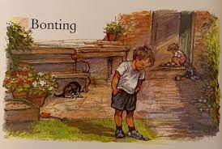  Instructions | Information Texts  Recounts  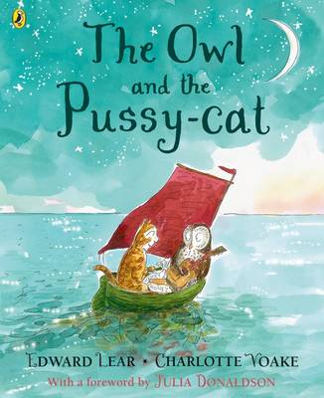  Poetry – Contemporary and Classic | Key Stories 2-  Meerkat Mail  Traditional Tales and Fairy Stories  Instructions  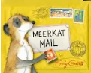 | Information Texts  Recounts  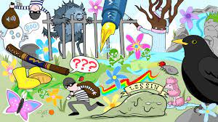  Poetry – Contemporary and Classic | Key Stories 3- The Tunnel  Traditional Tales and Fairy Stories  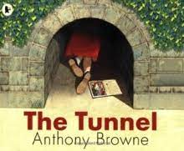 | Information Texts  Explanations  Poetry Contemporary and Classic  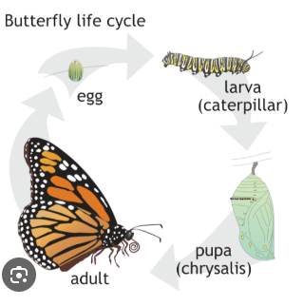
MATHS | 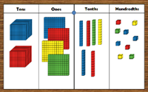  Place Value  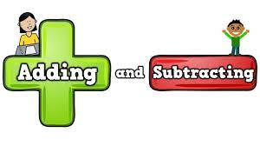  Addition and Subtraction | 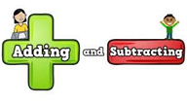  Addition and Subtraction  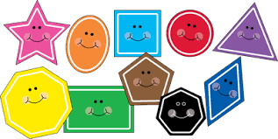  Properties of Shape | Properties of Shape  Money      Multiplication and Division | Multiplication and Division  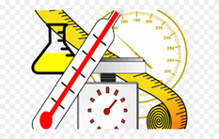  Length and Height  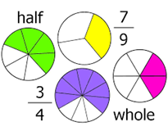  Fractions |   Fractions Statistics  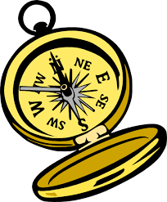  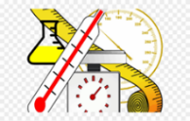  Time Position and Direction  Length and  Height Mass, Capacity and Temperature | Time  Position Length/Height  Mass, Capacity and Temperature
HISTORY |  | 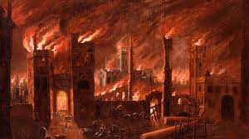  Great Fire of London |  | 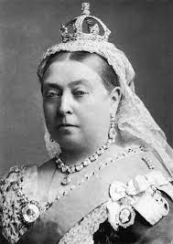  Queen Victoria’s influence |  | 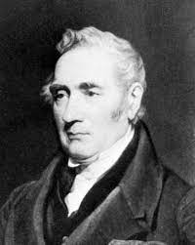  George Stephenson
GEOGRAPHY | 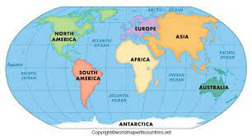  Continents and Oceans |  | 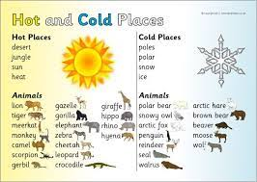  Hot and Cold |  | 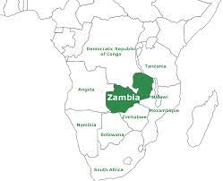  A Village in Zambia
SCIENCE | 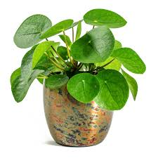  Plants | 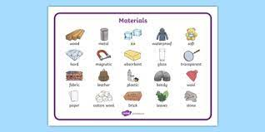  Materials | 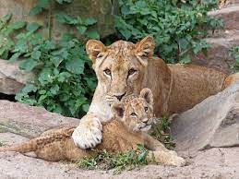  Animals including Humans (Baby to Adult) |  | 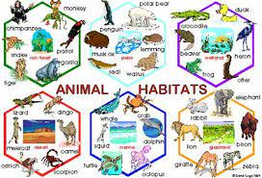  Living Things and Their Habitats | 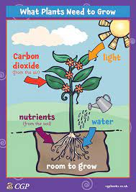  Plants – What does a seed need to grow?
COMPUTING | 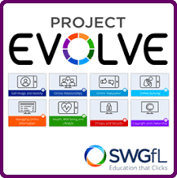  Digital Literacy (SWGfL – Project Evolve) | Digital Literacy (SWGfl – Project Evolve) |   Computer Science    Code.org (Course B) |   Microbits  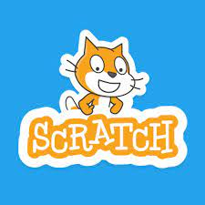  Scratch Jr |   Book Creator    I Can Animate | Book Creator  I Can Animate
P.E. | 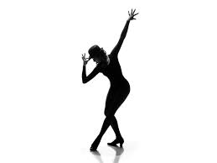  Dance  Fundamental movement and team games : Using Space |   Gymnastics (Floor)  Fundamental movement and team games: Attacking and defending | 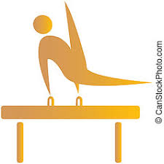  Gymnastics (Apparatus)  Fundamental movement and team games Throwing and catching a ball | Dance  Fundamental Movement and team Games: Striking and hitting a ball | 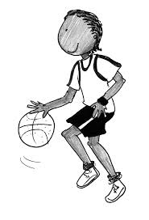  Fundamental Movement and Team Games: Travelling with a ball.  Fundamental Movement and team Games: Running jumping, throwing | 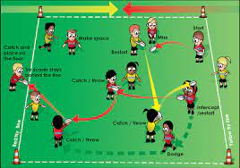  Fundamental Movement and team Games: Passing a ball/ using space  Fundamental Movement and team Games: Running, Jumping, Throwing
R.E. | 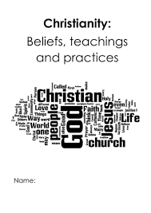  Christian Beliefs and Practices | 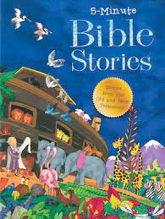  Teaching Christianity through Stories | 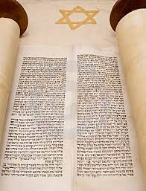  Judaism (Torah and the Shabbat) |   Meanings within Easter | 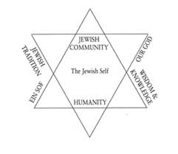  Judaism (Beliefs and Practices) | 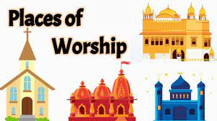  Places of Worship
D.T. |  | 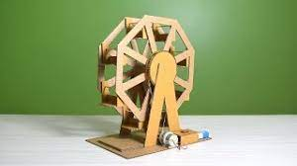  Mechanisms (Ferris Wheel) (3 lessons)  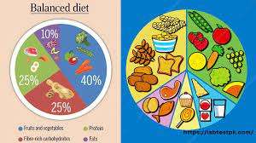  Food (Balanced Diets) (3 lessons) |  | 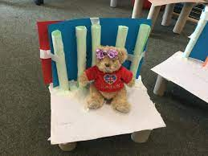  Structurers (Baby Bear’s Chair) |  | 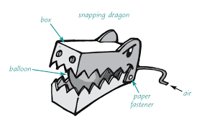  Mechanisms (Making a Moving Monster) (3 lessons)  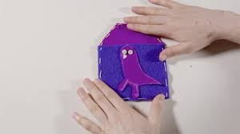  Textiles (Pouches) (3 lessons)
ART | 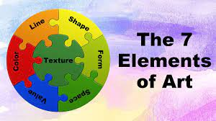  Formal Elements |  | 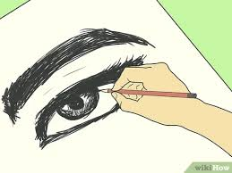  Skills |  | 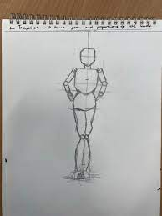  Human Forms
MUSIC | 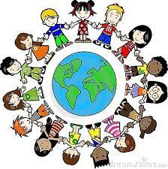    Making friends with Music | 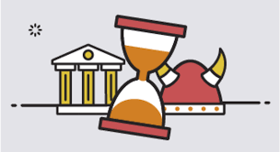  Music about our past |   Music to make the world a better place | 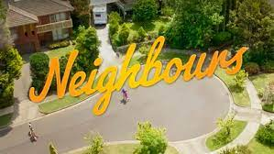  Music to understand our neighbours | Music shaping our life   |   Music to look after our planet
PHSE | Families and relationships (7 Weeks) Health and wellbeing (7 weeks) Safety and the changing body (9 weeks) Citizenship (7 weeks)    Economic wellbeing (6 weeks)  Health and wellbeing  Safety and the changing body


Challenge, Equality & Opportunity

