YEAR 1 | AUTUMN TERM 1 | AUTUMN TERM 2 | SPRING TERM 1 | SPRING TERM 2 | SUMMER TERM 1 | SUMMER TERM2
ENGLISH | Traditional Tales  Key Stories 1 – The Magic Porridge Pot  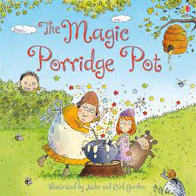  Information Texts | Key Stories 2- Room on the Broom  Instructions  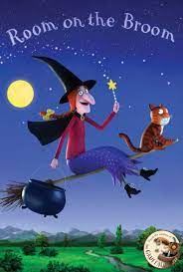  Poetry – Mudlarks – Shirley Hughes | Key Stories 3- Jack and the beanstalk  Traditional Tales  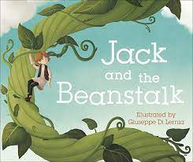  Information Texts | Key Stories 4 – Where the Wild Things Are  Recounts  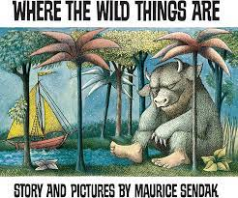  Poetry – Wish you were here by Colin McNaughton | Key Stories 5- Paddington’s Post  Instructions  Recounts  Information Texts  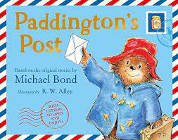  Poetry – On the Ning Nang Nong by Spike Milligan | Key Stories 6 – The Smeds and the Smoos  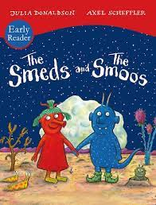  Traditional Tales
MATHS | 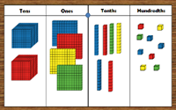  Place Value  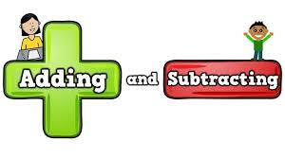  Addition and Subtraction | 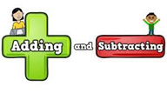  Addition and Subtraction  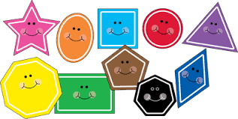  Properties of Shape | Place Value  Addition and Subtraction | Place Value  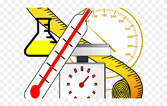  Length and Height/Mass and Volume | Multiplication and Division    Fractions  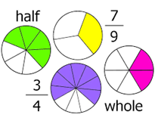  Position and Direction   | Place Value  Money    Time  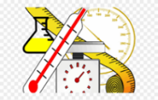
HISTORY |  | 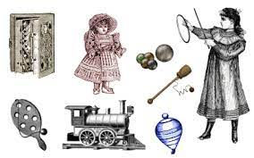  Childhood |  | 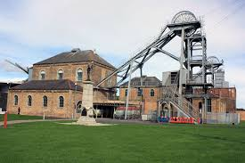  Mining in the Local Area |  | 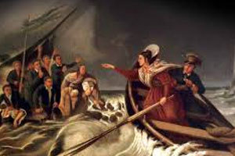  Grace Darling
GEOGRAPHY | 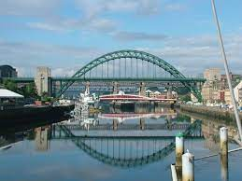  Where We Live |  | 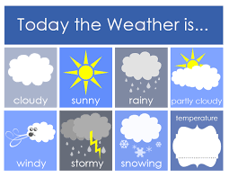  The Weather |  |   The UK
SCIENCE | 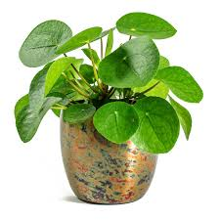  Plants | 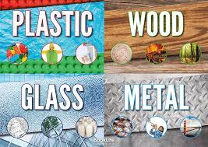  Everyday Materials  Animals including Humans  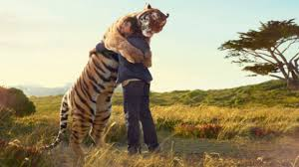 | 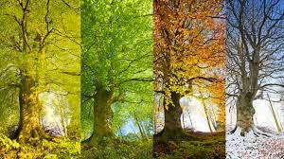  Seasonal Change | Animals including Humans | 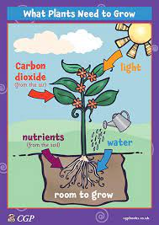  Plants | Everyday Materials
SCIENCE | Seasonal Change – Whole Year Focus
COMPUTING |   Digital Literacy (SWGfL – Project Evolve) | Digital Literacy (SWGfl – Project Evolve) |   Computer Science    Code.org (Course A) |   Microbits  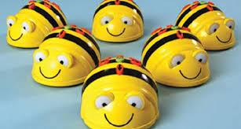  BeeBots |   SeeSaw    Book Creator |   Pic Collage    Green Screen
P.E. | 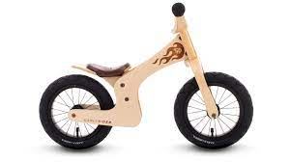  Balance Bikes  Fundamental movement and team games : Using Space (NUF)   | 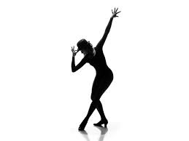  Dance  Fundamental movement and team games: Attacking and defending (NUF) | 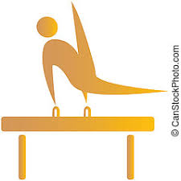  Gymnastics (Apparatus)  Fundamental movement and team games Throwing and catching a ball (NUF) | Dance  Fundamental Movement and team Games: Throwing and Catching (NUF) | 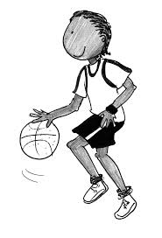  Fundamental Movement and Team Games: Travelling with a ball.    Fundamental Movement and team Games: Running jumping, throwing (Sports Service) | 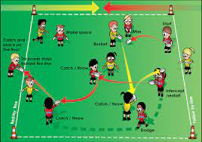  Fundamental Movement and team Games: Passing a ball/ using space  Fundamental Movement and team Games: Running, Jumping, Throwing (Sports Service)
R.E. | 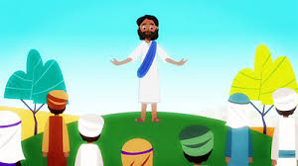  Christian Beliefs and Practices | 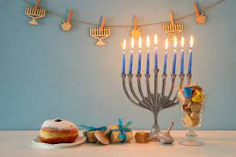  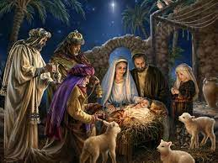  Teaching Christianity through Stories | 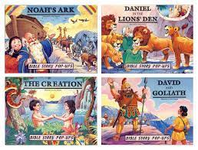  Introduction to the Bible through stories |   Meanings within Easter | Introduction to Islam   |   Ideas about God in Christianity and Judaism
D.T. |  | 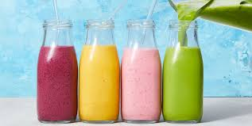  Food and Nutrition (Smoothies) |  | 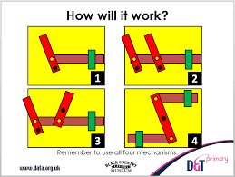  Mechanisms (Sliding Picture Books) |  | 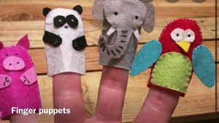  Textiles (Puppets)
ART | 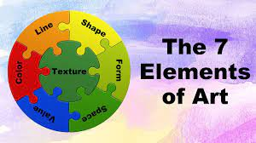  Formal Elements |  | 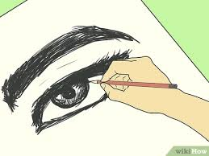  Skills |  |   Landscapes using different media (Seascapes)
MUSIC | 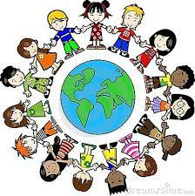    Making friends by singing |   Music about our past |   Music to make the world a better place | 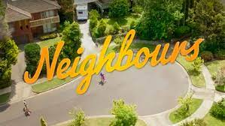  Music to understand our neighbours | Music to help us through the day   |   Music to look after our planet
PHSE | Zones of Regulation  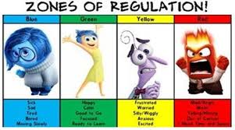 | Zones of Regulation | Zones of Regulation |   Family and Relationships | Safety and the changing body | Economic Wellbeing


Challenge, Equality & Opportunity

