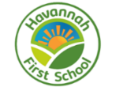
Challenge, Equality & Opportunity
Havannah Reads
At Havannah First School, we believe that all children should have experienced a wide variety of high quality texts and authors by the time they leave us in Year 4. We have devised a set of core texts for each class so that our children are able to successfully navigate reading with confidence. These texts have been chosen for their breadth and greater complexity, demanding more from the reader than other types of books.
We have chosen books using the ‘Pie Corbett Reading Spine’ and also the ‘Reading Reconsidered Reading Spine’ based on Doug Lemov’s ‘5 Plagues of the developing reader’. With our text selection, we have ensured that children are reading a wide range of text types such as:
- Archaic texts- where vocabulary is typically more complex than in books today, e.g. ‘Charlotte’s Web’ by E.B White
- Books containing non-linear sequences-where time moves back and forth. e.g. ‘Voices in the Park’ by Anthony Browne
- Narratively complex texts-when books are sometimes narrated by an unreliable narrator, non-human or multiple narrators, e.g.’ The Day the Crayons Quit’ by Drew Daywalt
- Symbolic texts-texts which happen on a symbolic level-E.g. ‘Where the wild things are’ by Maurice Sendak
- Resistant texts- texts written to deliberately resist easy meaning-making by readers. Perhaps half of the poems ever written fall into this category. You have to assemble meaning around nuances, hints, uncertainties and clues, e.g. ‘Not now Bernard’ by David McKee

Across the year, the chosen texts are shared with the children. Some texts are read purely for pleasure, while some are used as a stimulus in reading and writing lessons.

Our poetry spine contains collections of poems that will also be shared with children across the year. The books in our poetry spine introduce children to the joy of verse and build poetry into our everyday curriculum.
Reception
Havannah Core Texts
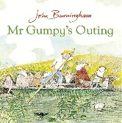
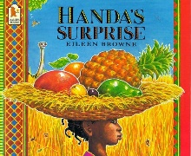
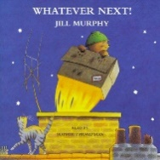

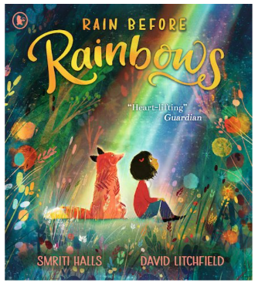
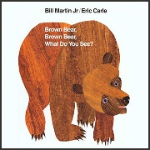
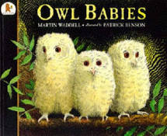

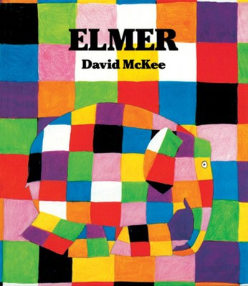
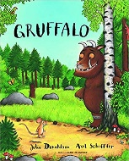
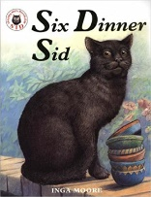
Challenge, Equality & Opportunity

Challenge, Equality & Opportunity
Year One
Havannah Core Texts

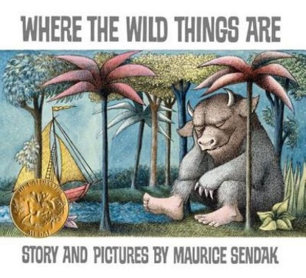
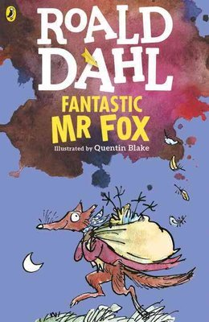
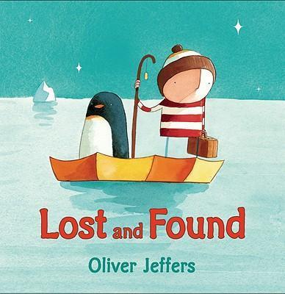

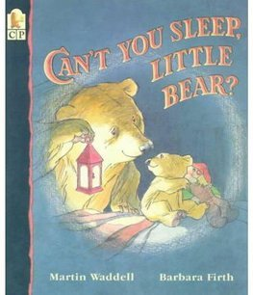
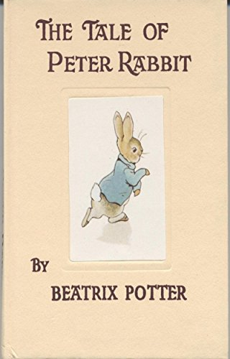
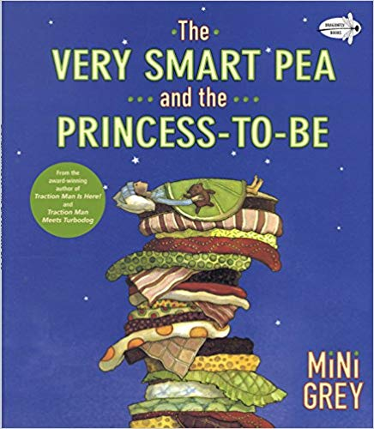
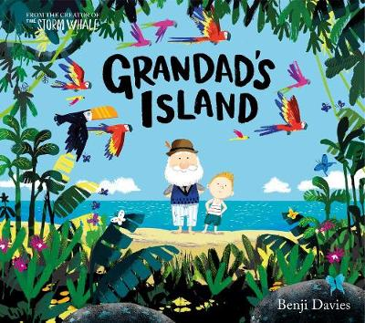
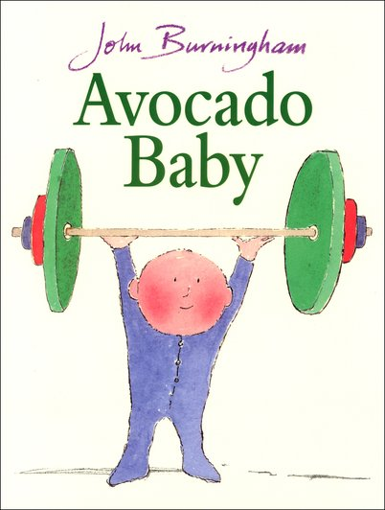
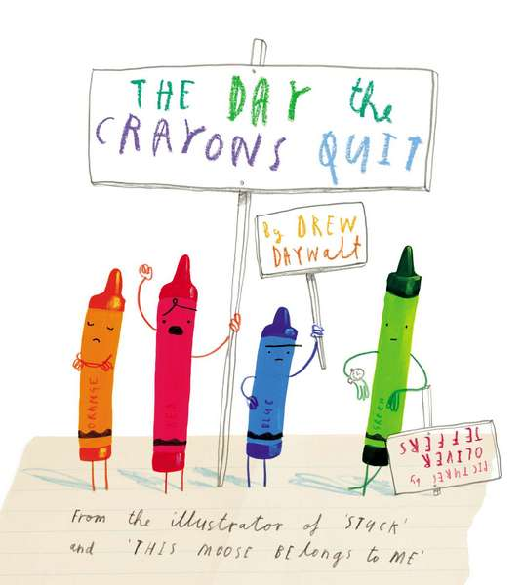
Year Two
Havannah Core Texts
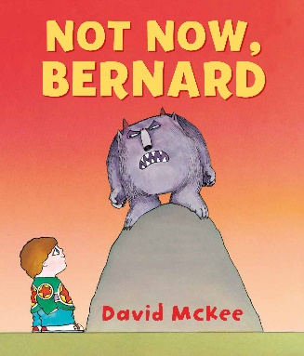
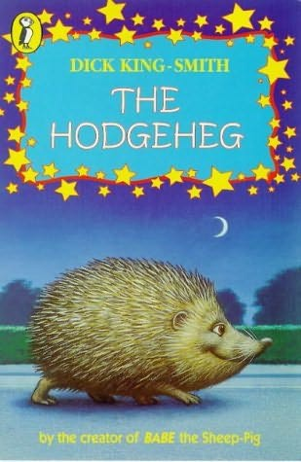

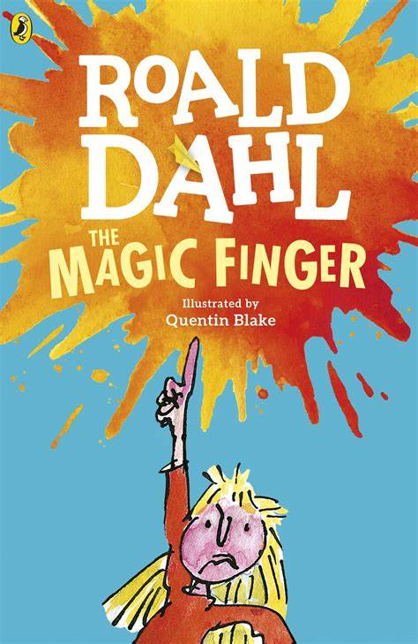
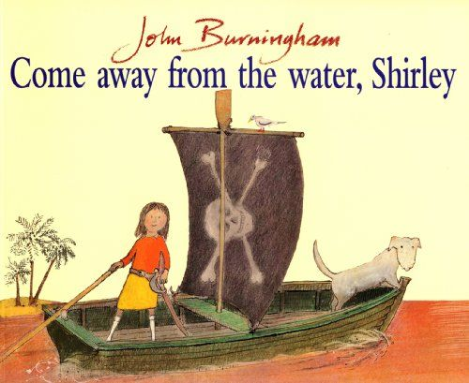
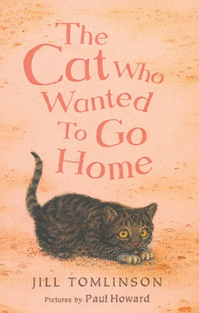

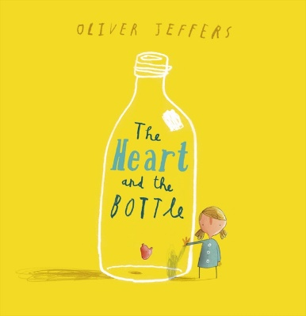
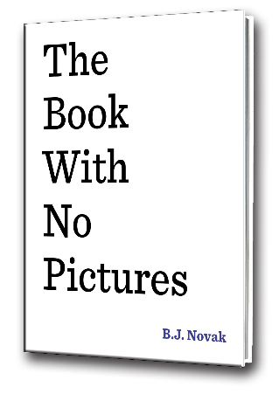
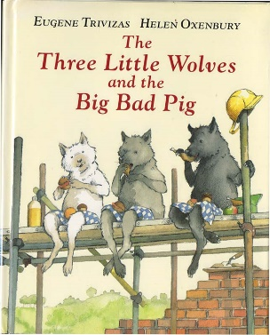

Challenge, Equality & Opportunity

Year Three
Havannah Core Texts

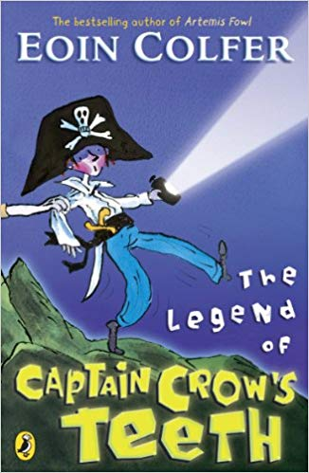
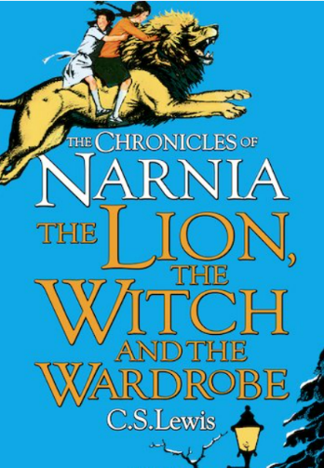
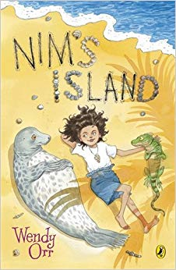

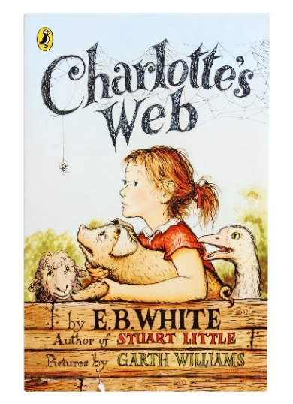
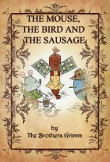
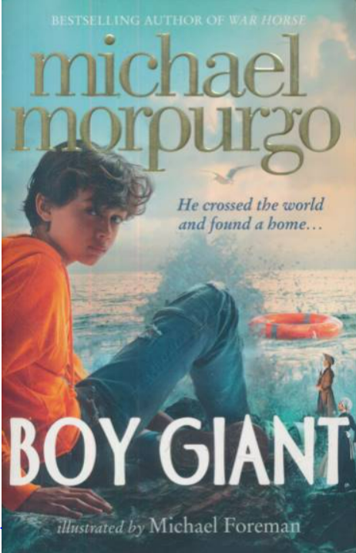
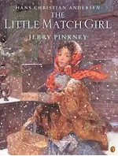

Challenge, Equality & Opportunity

Year Four
Havannah Core Texts
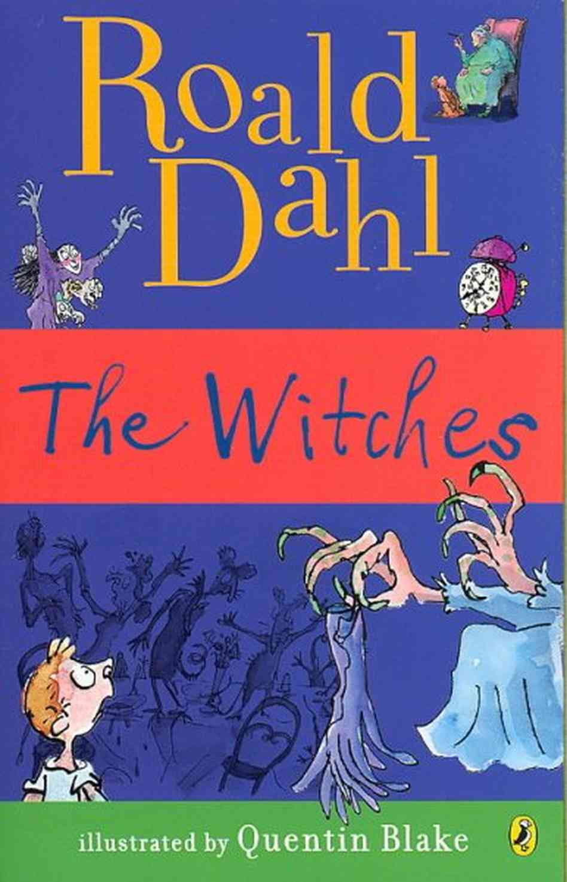
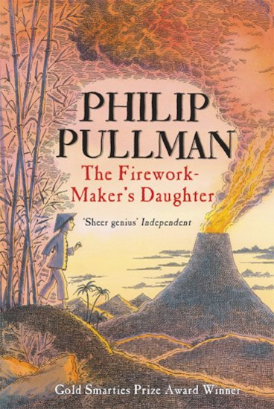
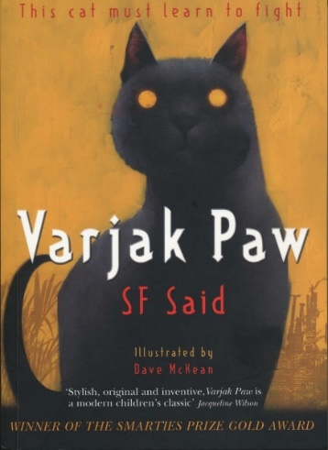

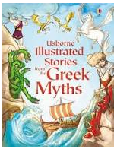
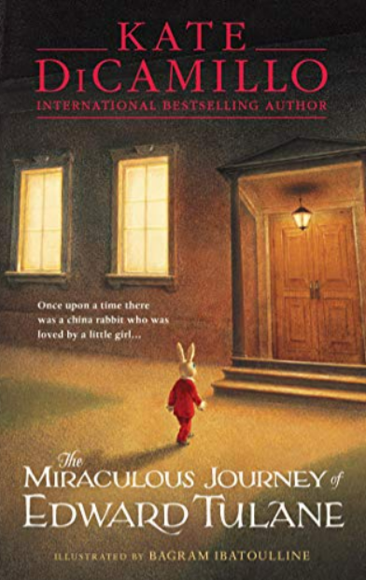
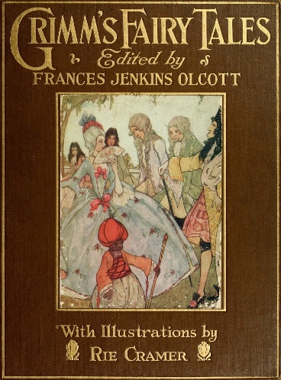
Challenge, Equality & Opportunity

Poetry Spine
Reception | Year One | Year Two | Year Three | Year Four
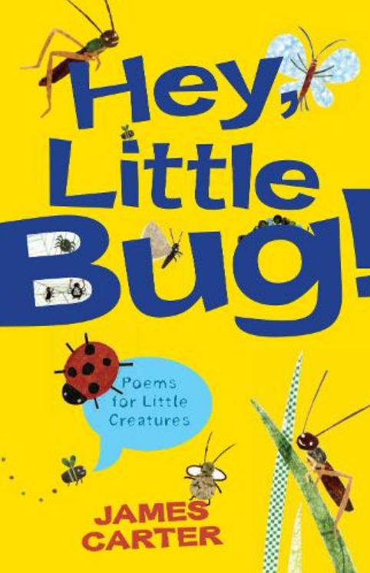  Hey, Little Bug!  James Carter  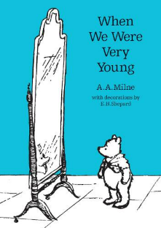  When We Were Very Young  A.A. Milne  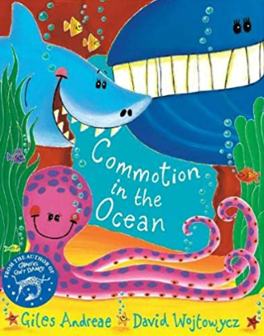  Commotion in the Ocean  Giles Andreae | 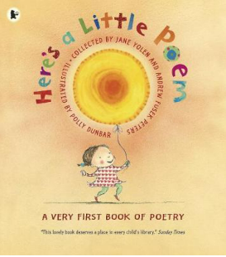  Here’s a Little Poem  Various authors  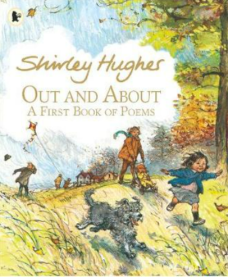  Out and About Shirley Hughes  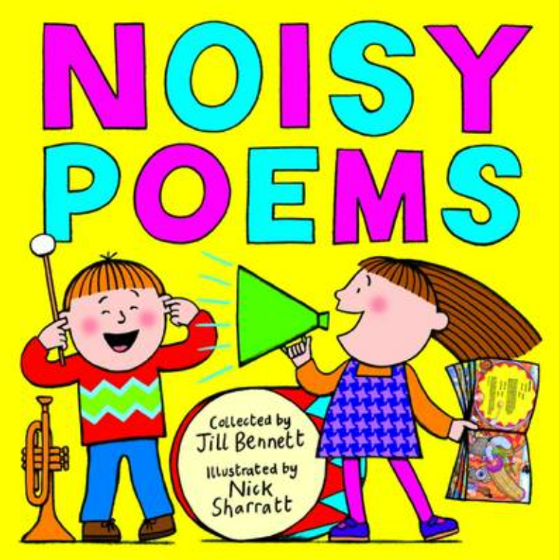  Noisy Poems  Collected by Jill Bennett | 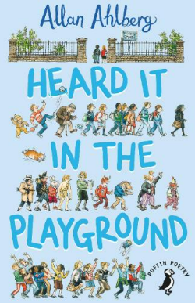  Heard It In The Playground  Allan Ahlberg  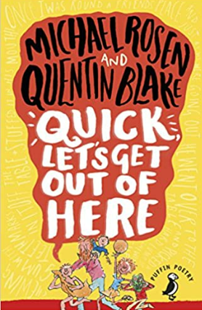  Quick Let’s Get Out of Here  Michael Rosen & Quentin Blake  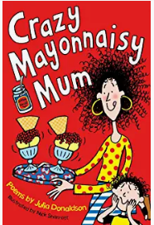  Crazy Mayonnaisy Mum  Julia Donaldson | 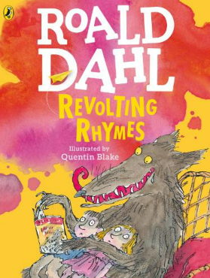  Revolting Rhymes  Roald Dahl  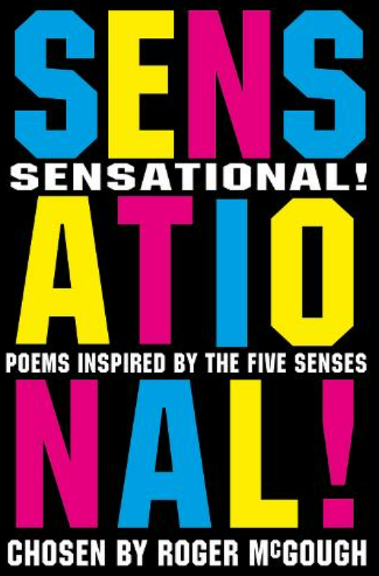  Sensational!  Chosen by Roger McGough  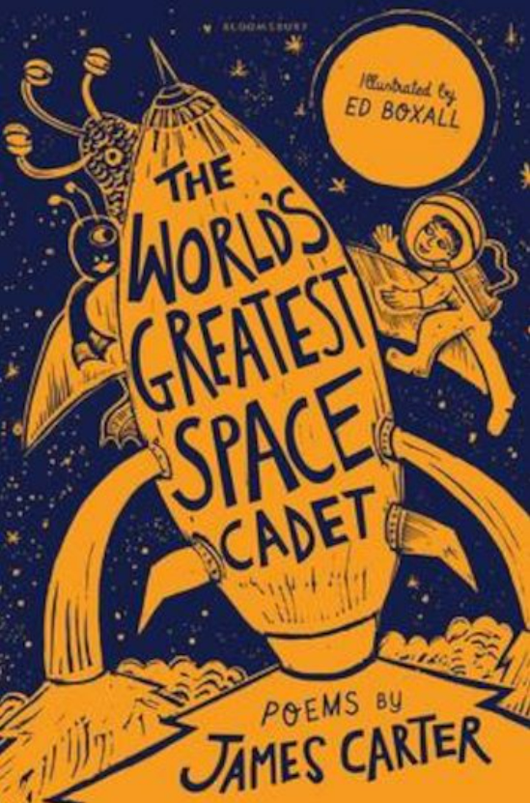  The World’s Greatest Space Cadet  James Carter | 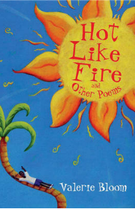  Hot like Fire Valerie Bloom  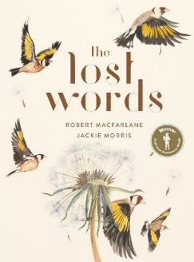  The Lost Words Robert Macfarlane Jackie Morris  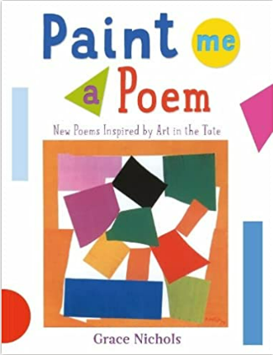  Paint Me a Poem  Grace Nichols
Challenge, Equality & Opportunity

