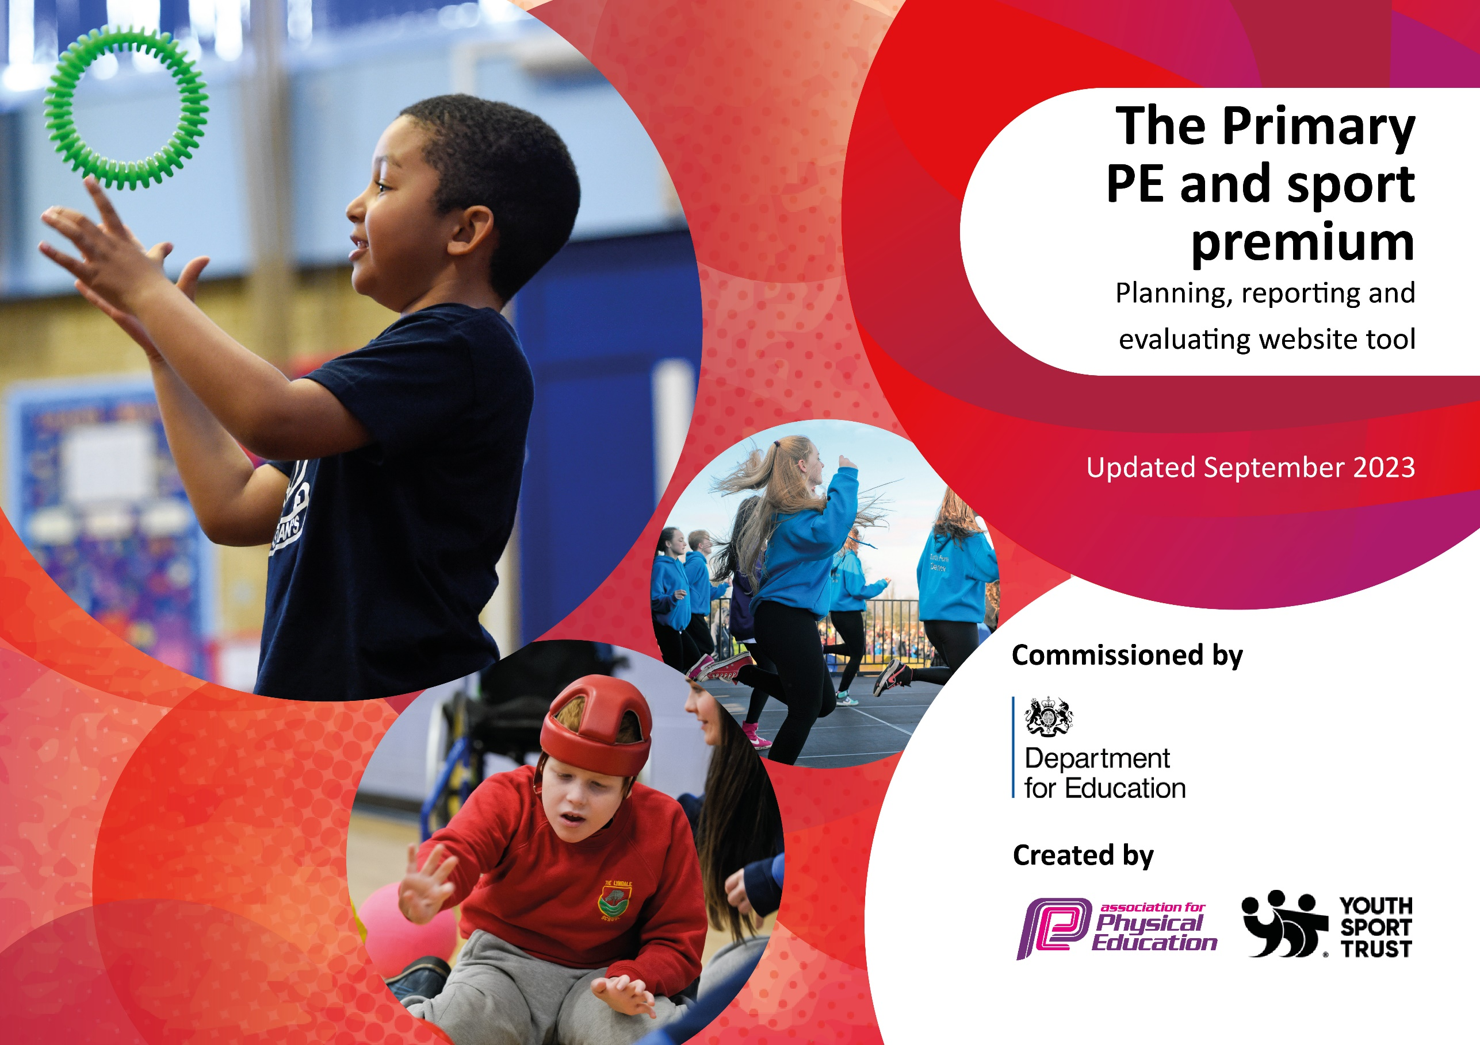

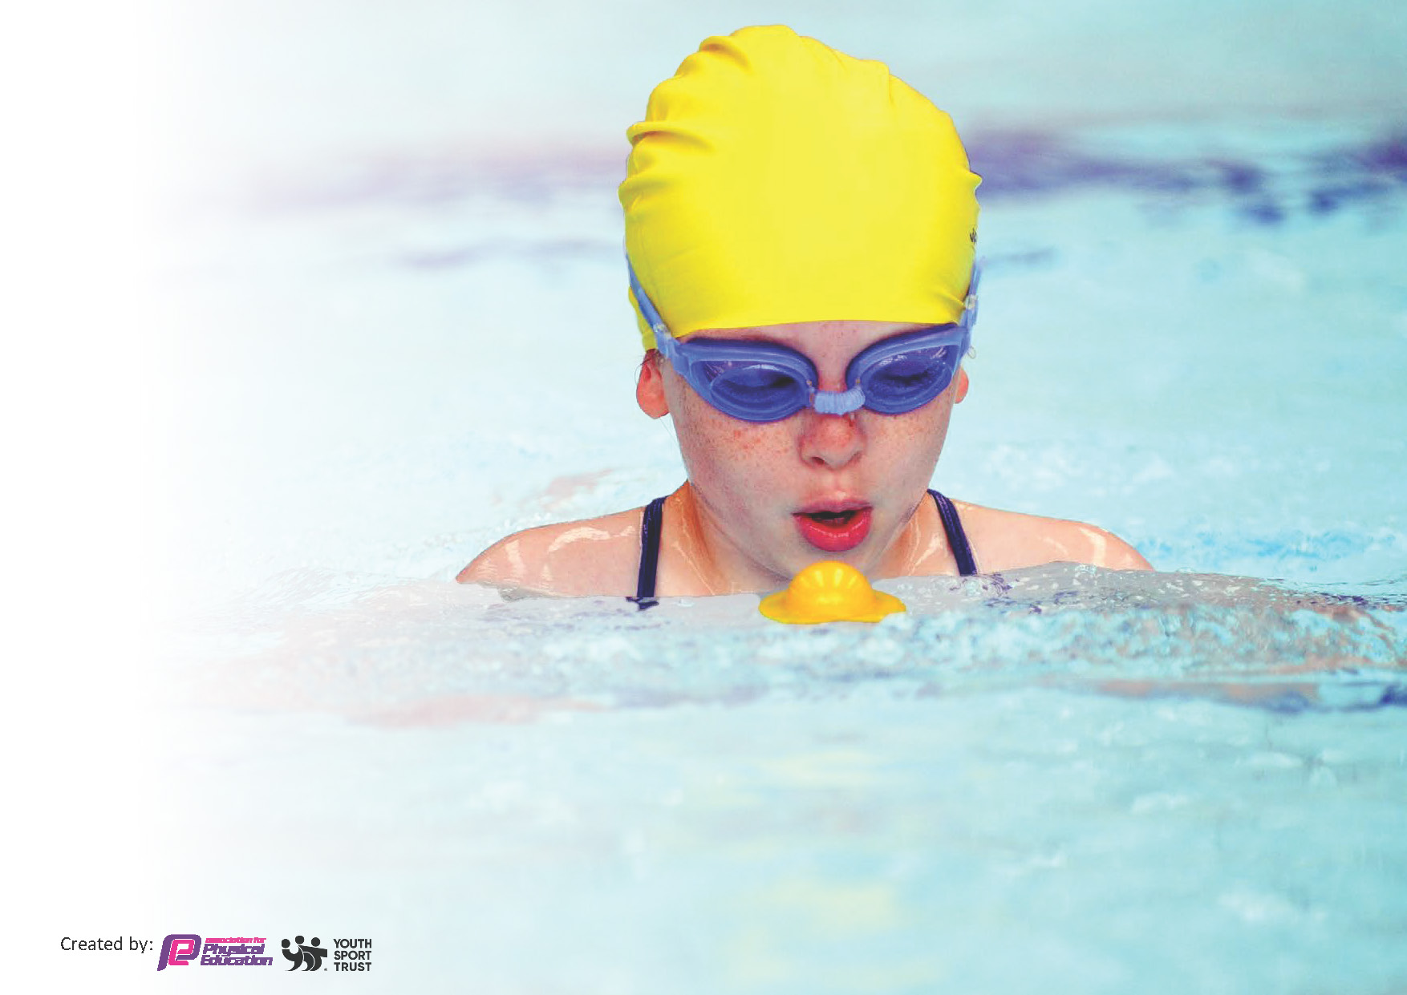
This template can be used for multiple purposes:
by:
- It enables schools to effectively plan their use of the Primary PE and sport premium
- It helps schools to meet the requirements (as set out in guidance) to publish information on their Primary PE and sport premium
- It will be an effective document to support Ofsted inspections enabling schools to evidence progress in Physical Education (PE) and evidence swimming attainment, which forms part of the PE National Curriculum. We would recommend schools consider
the Intent, Implementation and Impact of any spend, as examined within the Education Inspection Framework.

It is important that your grant is used effectively and based on school need.

Schools must use the funding to make additional and sustainable
improvements to the quality of the PE, School Sport and Physical Activity (PESSPA)
they offer. This means that you should use the Primary PE and sport premium to:

- Build capacity and capability within the school to ensure that improvements made now will benefit pupils joining the school in future years
- Develop or add to the PESSPA activities that your school already offers.

The Primary PE and sport premium should not be used to fund capital spend projects; the school’s core budget should fund these. Further detail on capital expenditure can be found in the updated Primary PE and sport premium guidance.

The Primary PE and sport premium guidance, outlines 5 key priorities that funding should be used towards. It is not

necessary that spending has to meet all the key priorities, you should select the priorities that you aim to use any funding towards.

Although completing this template is not a requirement for schools, schools are required to publish details of how they spend this funding. Schools must also outline what the impact this funding has had on pupils’ PE and sport participation and attainment and how any spending will be sustainable in the future. All funding must be spent by 31st July 2024.

The Department for Education has worked closely with the Association for Physical Education (afPE) and the Youth Sport Trust (YST) to develop this template and encourages schools to use it. This template is an effective way of meeting the reporting requirements of the Primary PE and sport premium.
Review of last year’s spend and key achievements (2022/2023)

We recommend you start by reflecting on the impact of current provision and reviewing your previous spend.

Activity/Action | Impact | Comments
- As part of our Covid Response we wanted to focus on cycling and ensure that all of our year 4 were able to ride a bike before they left us in July, to help them to access an active healthy lifestyle.  - Newcastle PE and School Sports service came in to deliver balance bikes in Year One, Cricket and tag rugby in Key Stage Two.  - NUF have delivered coaching sessions from Reception to Year 4 across the year, teaching fundamentals in Reception and Key Stage One and Football/ Tennis in Key Stage Two.  - Newcastle PE and School Sports Service ran a whole school athletics CPD session for staff. | - All of our Year 4 non- riders were able to ride a bike by the end of the coaching.  - Staff across the whole school have been upskilled in teaching these areas of the curriculum.  - Monitoring of PE lessons has shown impact through the quality teaching of key skills linked to our progression document and planning provided by Newcastle PE School Sports Service.  - A PE Deep Dive carried out by our School Improvement Partner found the teaching of PE to be good.  - A subsequent Ofsted Deep Dive found PE to be well developed as a subject, with strong progression documentation. Joint lesson observations between the inspector and PE lead found strong evidence of high quality teaching of PE where lessons included technical vocabulary and clear modelling of key skills. Children across school were able to talk about PE and what they enjoyed, as well as being able to explain what they were learning and how they could improve. | We plan to continue with a high level of coaching in 2023-24 to further develop staff knowledge across the areas of PE.  We also have two new members of staff including an ECT who will benefit from CPD through visiting coaches.

Key priorities and Planning
This planning template will allow schools to accurately plan their spending.

Action – what are you planning to do | Who does this action impact? | Key indicator to meet | Impacts and how sustainability will be achieved? | Cost linked to the action
To upskill staff in different areas of PE across the school year.  To employ coaching staff during lunchtime play.  To teach children basic skipping skills.  To provide a variety of play equipment.  To offer a range of year groups a range of different sporting activities and competitions through our engagement with the Schools 500 and Gosforth Gets Going tournaments.  A squash taster session for Year 3 children.  Gosforth Gets Going Taewkwondo festival  To engage with the school games competitions as well as inter school competitions within our school trust. | School staff who will receive valuable CPD and pupils who will benefit from varied coaching.  Children from both Key Stage One and Key Stage Two will have opportunities to play ball games at lunchtime play.  Children in Reception and Key Stage One.  All children in all key stages across school.  This year we took part in:  Schools 500  Key Stage One Multi-skills  Key Stage Two Boys Football  Key Stage Two Handball  Year 3 children.  Key Stage Two Children  Key Stage Two children. | Key Indicator 1: Increased confidence, knowledge, and skills of all staff in teaching PE and sport.  Key indicator 2 -The engagement of all pupils in regular physical activity – the Chief Medical Officer guidelines recommend that all children and young people aged 5 to 18 engage in at least 60 minutes of physical activity per day, of which 30 minutes should be in school.  Key indicator 2 -The engagement of all pupils in regular physical activity  Key indicator 2 -The engagement of all pupils in regular physical activity  Key indicator 4: Broader experience of a range of sports and activities offered to all pupils.  Key indicator 4: Broader experience of a range of sports and activities offered to all pupils.  Key indicator 4: Broader experience of a range of sports and activities offered to all pupils.  Key indicator 5: Increased participation in competitive sport. | Staff have been upskilled and given planning in different areas of PE that can be used for the future delivery of PE in school.  More pupils meeting their daily physical activity goal, more pupils encouraged to take part in PE and Sport Activities.  With increased confidence and the skills to skip, more children will be able to skip and keep active at playtime.  This equipment will be used to keep more children active at playtimes and during PE lessons.  Children from both Key stage One and Two were given competitive opportunities in a range of different sports. This will open up more opportunities to participate in sport in the future.  We have maintained this link with Northern Squash for many years. Some of our ex pupils who have taken up squash as a result of this introduction have gone on to compete in squash at both a local and national level.  Children enjoyed the opportunity to take part in a trust taekwondo festival. This has encouraged more children to consider taking up Taekwondo – our early morning club.  Children have enjoyed taking part in different competitions against children from across our trust and across Newcastle.  We have taken part in  - School Games Quadkids event.  - Cricket tournament  - Pyramid Football tournament  - Girls’ Football tournament  - Orienteering competition  We have gained the School Games Gold award again this year which reflects our commitment to and engagement with the games on offer. | NEAT support Gold SLA  £7,660.00  NUF Primary Stars Bronze programme:  £6,700.00  Lee Sterry Sports  £570.00  Skip4Fit Skipping Day  - £280.00  Skip4Fit Rope Box  - £150.00  Hoop storage bag  - £9.17  Plastic base  - £25.49  Sponge balls  - £31.47  Hoops  - £29.88  - £15.01  Spot markers  - £14.97  Jumping balls  - £63.96  Storage tub  - £26.07  Rabo Scooters  - £333.99  Skipping ropes  - £11.99  Hoola hoops  - 27.99  Jump bands  - £11.49  500 Games transport  - £285.00  - £150.00  500 Games entry  - £105.00  Richard Vitty Squash Taster sessions  - £60.00  Taekwondo transport  - £100.00  Girls Football Transport  £125.00  Quadkids transport  £150.00  Cricket Transport £125.00  Lee Sterry GST £30.00  Lee Sterry  Pyramid Football £60.00  Newcastle Schools FA  £30.00  Total Spend  £18,46.48

Key achievements 2023-2024
This template will be completed at the end of the academic year and will showcase the key achievements schools have made with their Primary PE and sport premium spending.

Activity/Action | Impact | Comments
In 2023-2024 a large portion of PE and Sport Premium was spent on coaching to upskill staff.  We used Newcastle PE and School Sport Service and Newcastle Foundation. | All staff including new staff and an ECT were upskilled in different areas of PE.  Feedback from staff has been positive and staff have been upskilled in the teaching of athletics, tag rugby, tennis, football and fundamental skills, including throwing and catching, striking and hitting a ball, using space, attacking and defending and travelling with a ball/ hitting a target. | Over the last few years we have had a large amount of coaching to upskill staff in different areas of PE. Moving forwards, we are planning on spending less on coaching and more of our money on resourcing PE and Active play. This will enhance our current provision in an expanding school and help to ensure that children are having their “active 30” every day.

Swimming Data
Meeting National Curriculum requirements for swimming and water safety.
Priority should always be given to ensuring that pupils can perform safe self-rescue even if they do not fully meet the first two requirements of the National Curriculum programme of study

Question | Stats: | Further context  Relative to local challenges
What percentage of your current Year 6 cohort can swim competently, confidently and proficiently over a distance of at least 25 metres? | NA | Use this text box to give further context behind the percentage.  e.g., 30% - we are struggling to get pool space due to our local pool closing so we have had to use a much smaller local school pool. We have had to limit the number of pupils attending swimming lessons during one term which means some pupils have attended fewer swimming lessons than others.
What percentage of your current Year 6 cohort can use a range of strokes effectively [for example, front crawl, backstroke, and breaststroke]? | NA | Use this text box to give further context behind the percentage.  e.g., Even though your pupils may swim in another year please report on their attainment on leaving primary school at the end of the summer term 2024

What percentage of your current Year 6 cohort are able to perform safe self-rescue in different water-based situations? | NA | Use this text box to give further context behind the percentage.
If your schools swimming data is below national expectation, you can choose to use the Primary PE and sport premium to provide additional top-up sessions for those pupils that did not meet National Curriculum  requirements after the completion of core lessons. Have you done this? | NA
Have you provided CPD to improve the knowledge and confidence of staff to be able to teach swimming and water safety? | No

Signed off by:

Head Teacher: | Helen McKenna
Subject Leader or the individual responsible for the Primary PE and sport premium: | Sally McMillan PE Lead
Governor: | Roxsanna Rutherford
Date:

